White Paper: biositemaps (http://en.wikipedia.org/wiki/Biositemaps)

Authors: The Biositemaps Consortium

V3.1
March 13, 2008

Description:
The Resourceome Working Group of the NIH Roadmap National Centers of Biomedical Computing (NCBC) (www.ncbcs.org/) proposes a biositemaps protocol to address the issues of (i) locating, (ii) querying, (iii) traversing, (iv) composing or combining, and (v) mining biomedical computing and computational biology software tools and information resources on the Internet. The working group recommends both an efficient technological approach and suggests that NIH leadership foster widespread adoption.

In brief, NIH recommends that all grantees, institutions, centers, departments, foundations, organizations, or users voluntarily generate and install an XML file (biositemap.xml) on their root web sites. For example, a component of the University of State instantiates www.UniversityofState.edu/component/biositemap.xml which describes attributes of all computational tools and informational resources which are developed, distributed, or used by this University’s component. Each site’s biositemap.xml conforms to a defined XSD schema and is tagged by a resource ontology.

Currently, a prototype schema, resource ontology, and related tools may be found at www.biositemap.org/. The prototype uses the schema www.ncbcs.org/biositemaps/biositemaps-v04.xsd and the resource ontology hierarchy is available at bioontology.org/projects/ontologies/SoftwareOntology/. The long-term plan is to maintain a permanent, stable Biomedical Resource Ontology (BRO), and a first draft can be found by navigating from the BioPortal web site http://alpha.bioontology.org/ (click browse and scroll down to Biomedical Resource Ontology and then click on explore). The corpus (content) of biositemap.xml may be discovered, interpreted, and used by anyone on the Internet by automatic web crawling discovery using a client, e.g., http://iTools.ccb.ucla.edu (click on Use iTools now!), by standard web-search engines, e.g., Google(filetype:xml biositemap), or by direct web-browser access using known biositemaps URLs. The corpus of biositemap.xml throughout the Internet will represent a distributed inventory of biomedical tools and information resources. The biositemaps consortium will provide user-friendly tools (GUIs) to help content providers create their biositemap.xml and also a ‘how to’ description at the www.biositemap.org/ site.

This approach borrows from the www.sitemaps.org initiative of Microsoft, Google, and Yahoo, e.g., Google(filetype:xml sitemap), but acknowledges the historical legacy of numerous computer science initiatives such as BioMoby, the Cancer Data Standards Repository, BIRNLex, and the Neuroscience Information Framework (NIF), and others which are in the list of References (Appendix C). With active leadership from NIH and other agencies, this conforming approach offers the possibility of a wide range of uses such as (i) locating, (ii) querying, (iii) discovery of resources, (iv) composing resources (e.g., software pipelines) across heterogeneous hardware and software environments, and finally (v) statistical data mining software tools and information resources. The functions of (i) locating, (ii) querying, and (iii) discovering of biositemaps and their resources are prototyped and visualizing biositemaps are prototyped in the iTools application http://iTools.ccb.ucla.edu/. The function of (iv) composition is a future extension of biositemaps which is expected to provide the ability to pipeline applications across the Internet either real time or at least in principle. There is a specific data-driven hands-on illustration of this protocol at www.loni.ucla.edu/twiki/bin/view/CCB/NCBC_iTools_PipelineIntegration and http://cms.loni.ucla.edu/iTools/integration.aspx). Finally, the (v) mining capability will provide the ability to evaluate usage, peer rating, and possibly provide hints about associations among applications, researchers, institutions, and scientific applications. Other than the above-mentioned utility that would arise out of widespread adoption, this approach has attributes of being distributed, un-intrusive, and scalable. There are a number of related efforts at NIH which should be engaged (Appendix B.1).

Technical Specification:
The content is the set of biositemap.xml files, which are each located in the root URL directories of biomedical institutions throughout the Internet. One of the attributes of biositemaps is that it is unobtrusive. Thus, biositemap content exists side-by-side with any existing or future method of inventorying or registering resources on the Internet. Biositemaps are also simple; the only controlled elements (or ‘standards’) are the XML schema(s) and the resource ontology(s) (the plan is to use the BRO as described above, which may be a single hierarchy or a cluster of hierarchies, and which is available on BioPortal http://alpha.bioontology.org/). The current prototype has developed a single schema and resource ontology. Parelleling sitemaps, so long as the schema remains technologically scalable (i.e. future versions are backward compatible) it may be possible to retain a single schema in perpetuity. This would be a significant achievement of leadership and would be enabled if the majority of key initiatives and programs at NIH were to endorse biositemaps. The current resource ontology has been built by the resourceome working group under the NCBCs (www.NCBCs.org/) in consultation with interested experts from the biomedical research community. Currently, the image processing community has been most represented and the ontology represents some maturation in that domain. The working group is reaching out to other domains and in each case we will work to develop a resource ontology which is useful and complete for that domain. Some domains will have sufficient complexity or existing classification schemes that may require extension to a cluster of resource ontologies. In this case the leadership issue will need to focus on (i) agreeing on a location where the Internet community can access the resource ontologies and (ii) working to minimize the number of resource ontologies consistent with provision of coverage as required by all interested domain communities. The following sections provide technical details about the prototype XML schema and resource ontology and how these are integrated into the biositemaps initiative.

1. XML Schema(s). The schema specifies required and optional attributes that describe resources. Each site chooses the granularity of resources (a) that are developed under the site’s own auspices or (b) which resources the site uses (and ‘finds useful’) and which are developed elsewhere. A good reference for XML editors is at http://en.wikipedia.org/wiki/Xml_editor (see also the tools listed under External Links). In the coming months we will develop a user-friendly web site so that biositemaps can be created using (hopefully simple) GUIs. The biositemap.xml file may also be created by hand (this is appropriate only for a site which intends to expose countably-few tools or information resources) or programmatically generated from existing inventories, clearinghouses, databases, or registries. The current prototype schema is defined at www.NCBCs.org/biositemaps/biositemaps-v04.xsd and is also described in Appendix A. Specific items to note are the use of both optional and required fields and the resource ontology field (see next section). New fields can be readily added so long as the process is reasonably constrained in such a way that old schema versions are maintained and new schema versions are backward compatible. Of the proposed new fields, two are key to the problem of composing tools and information resources: API, and Web Services (not shown in Appendix A). Descriptions of APIs and Web Services (anonymous ftp, CVS download, Grid Access, Databases, etc.) may enable semi-automated discovery and composition (real-time or by delayed association) of applications across geographically dispersed and heterogeneous software and hardware environments. The goal is to do this in a scalable, reusable, and decentralized manner. This is clearly a long-term goal. The Neurscience Information Framework has already made progress in that area, however version 1.0 of biositemaps will simply provide only a placeholder for this functionality. We are considering migrating the technology from XML to OWL in the near future in order to guarantee forward compatible with these kinds of semantic web functionality.

2. Resource Ontology. The prototype resource ontology can be viewed in Protégé output format at bioontology.org/projects/ontologies/SoftwareOntology/. The elements of the ontology (formally ‘classes’) are intended to be entered into the appropriate attribute field of each biositemap.xml (Appendix A) and thus provide sensitivity and specificity which can be used by applications which mine the biositemap.xml files on the Internet. The prototype resource ontology is a hierarchical set of controlled classes which are connected by the classification, sometimes called ‘is-a’, relationship. The control is implemented through an API which is planned to be implemented at www.ncbcs.org/biositemaps/resourceontology/api and thus used by tools which mine the System to validate resource entries.

Commentary on Technical Specification:
1. Distributed/Decentralized: The content of biositemaps are the distributed set of biositemap.xml files on root URL directories across the Internet associated with grantees, institutions, centers, departments, foundations, organizations, or users. For example, the university of State department of biochemistry instantiates www.UniversityofState.edu/biochemistry/biositemap.xml which describes attributes of computational tools and informational resources which are developed, distributed, or used by the biochemistry department. It does not matter if other grantees, institutions, centers, departments, foundations, organizations, or users report on the same tool; indeed multiple reports will be an additional parameter that will aid data mining of the distributed information resource across the Internet. The design principles of biositemaps are: simplicity, minimal central control and management, and avoid closing the door to future development paths. The minimal set of managed entities are the XML schema(s) and biomedical Resource Ontology(s) as described in the technical specification.

2. Un-intrusive and Reusable: The content of biositemaps are the distributed set of biositemap.xml files on root directories across the Internet associated with biomedical research institutions, users, foundations, or organizations. This requires maintenance on the part of participating institutions either to create a new biositemap.xml file from scratch using an XML Editor tool, or to use an automated software algorithm to extract relevant information from existing registries or inventories. Biositemaps does not require that outside access conform to any particular visualizing or mining tool; indeed, one of the strengths is that anyone on the Internet can automatically find the content by crawling, e.g., Google (filetype:xml biositemap), and that this content can be used in any appropriate way. Regardless of how the biositemap.xml files are created, they may co-exist with any other method for query, browse, composition, or mining. The key issue relating to leadership is that interested parties promote a minimal biositemaps schema and resource ontology, and that these be in a persistent, well-known location on the Internet.

3. Scalable: The key leadership issue is to limit the expansion of the XML schema and resource ontologies. New attributes may be added relatively easily to the schema without breaking tools that use the biositemap.xml files, and the future implementation of attributes for API and Web Services may lead to improved ability to compose and mine information tools and resources across the Internet. We are considering migrating the technology from XML to Resource Description Framework (RDF) or OWL web ontology language in the near future in order to guarantee forward compatible with these kinds of semantic web functionality.

Leadership Issues: The key issue relating to leadership is that interested parties promote a minimal biositemaps schema and resource ontologies, and that these be in a persistent, well-known location on the Internet.

Appendix A: Prototype Biositemaps XML Schema

The current version (v04) of the XML Schema which is used to generate the biositemaps.xml content across the NCBC Centers is (www.NCBCs.org/biositemaps/biositemaps-v04.xsd). For example, the biositemaps.xml which is currently on the NCBC National Center for Integrative Biomedical Informatics (NCIBI) portal (https://portal.ncibi.org/portal) was generated using this schema and the tool ‘XMLmind’ http://www.xmlmind.com/xmleditor/. The list of defined metadata elements is currently (March 2008) being formalized by the Resourceome working group—a minimal set is as follows:
- Resource Name
- Resource Description
- Resource Authors
- Release Version
- Keywords
- Ontology Label
- Data Input and Output (this currently needs further specification)
- Supported Platforms
- License
- Organization
- URL

Commentary: Future versions of the biositemaps schema are expected to have fields to define data types and query interfaces for both online data services and online analytic services. Future versions may also leverage the Resource Description Framework (RDF) or the OWL web ontology language to improve the use of Web Services in such a way that on-line applications can be composed and mined. This is a scalable, future extension of biositemaps.

Appendix B: Biomedical Resource Ontology

The prototype biositemaps uses the resource ontology http://bioontology.org/projects/ontologies/SoftwareOntology/. The long-term plan is to maintain a Biomedical Resource Ontology (BRO), and a first draft can be found by navigating from the BioPortal web site http://alpha.bioontology.org/.

Appendix C: References

- Other similar initiatives: http://www.loni.ucla.edu/twiki/bin/view/CCB/NCBC_ToolIntegration_XMLtology_2006_OtherArchives. Related efforts (not limited to): OpenArchives http://www.openarchives.org/; Protocol for Web Description Resources (POWDER) Working Group (POWDER) http://www.w3.org/2007/powder/; Open Directory Project http://www.dmoz.org/index.html

- The current list of biositemap.xml files (basically, the NCBC prototype) can be accessed by Google(filetype:xml biositemap).

- Sitemaps.org: consortium of Microsoft, Google, and Yahoo to improve web searching http://www.sitemaps.org/

- The BioMoby initiative has very similar objectives as biositemaps http://biomoby.org/

- Cancer Data Standards Repository http://ncicb.nci.nih.gov/NCICB/infrastructure/cacore_overview/cadsr

- Society for Neuroscience Database Gateway has experimented with a similar effort http://ndg.sfn.org/; the Neuroscience Information Framework (NIF) initiative has experimented with a similar effort
- http://neurogateway.org/catalog/goto.do;jsessionid=F8D6AC6F12C236FB082879CF3D24867C?page=.home

- XML Editors: http://en.wikipedia.org/wiki/Xml_editor, see tools under external links, e.g., the biositemaps.xml which is currently on the NCBC National Center for Integrative Biomedical Informatics (NCIBI) portal (https://portal.ncibi.org/portal) was generated using the tool ‘XMLmind’ http://www.xmlmind.com/xmleditor/

- Dinov, ID., Rubin, D., Lorensen, W., Dugan, J., Ma, J., Murphy, S., Kirschner, B., Bug, W., Sherman, M., Floratos, A., Kennedy, D., Jagadish, HV., Schmidt, J., Athey, B., Califano, A., Musen, M., Altman, R., Kikinis, R., Kohane, I., Delp, S., Parker, DS., Toga, AW., (2008) iTools: A Framework for Classification, Categorization and Integration of Computational Biology Resources. In review.

Appendix D: Graphical Illustrations

The figures below demonstrate visually the core infrastructure and utilization of Biositemaps.

- Construction of Biositemap.xml file
  - Gather the Resourceome inventory that needs to be biositemapped.
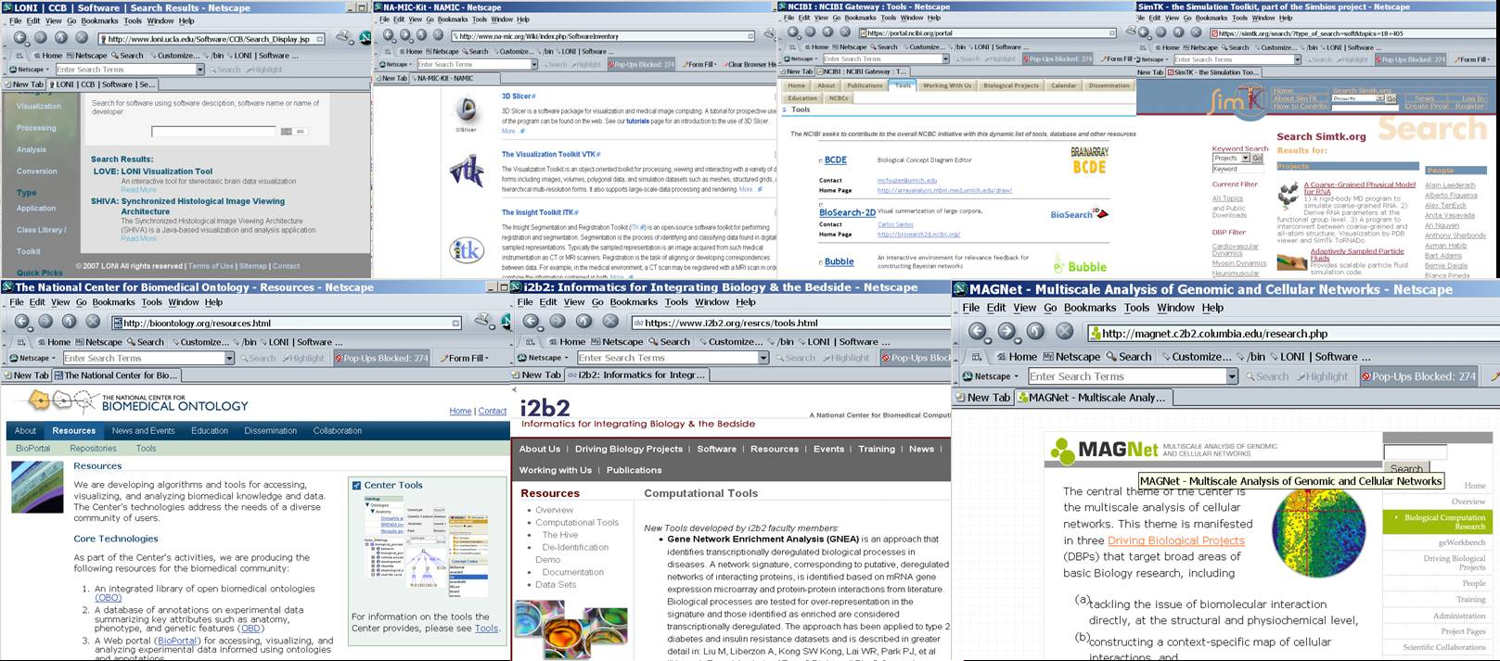

  - Export as much Resourceome information automatically as possible.
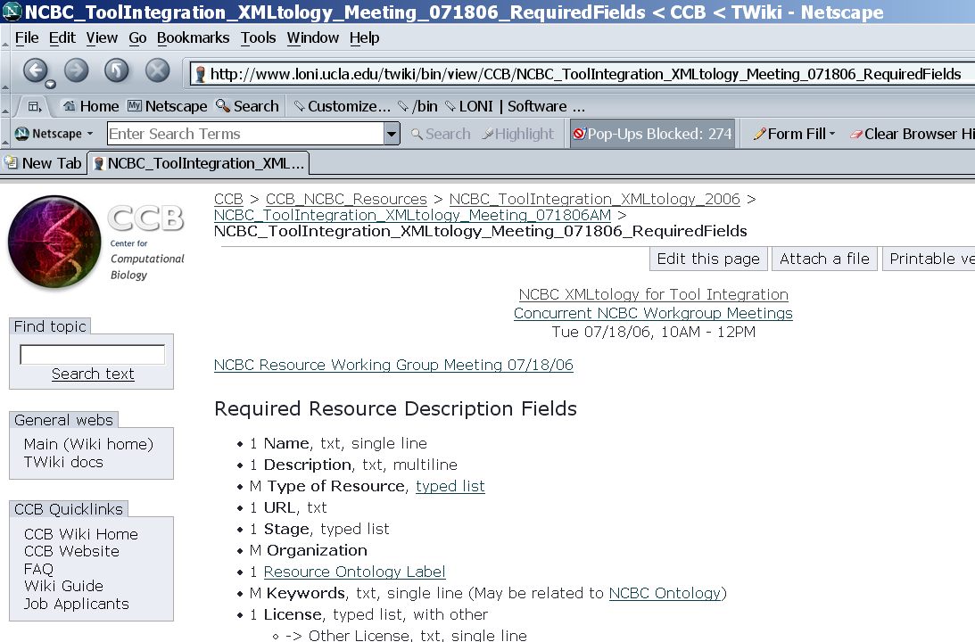

  - Manually complete the missing information for each resource description

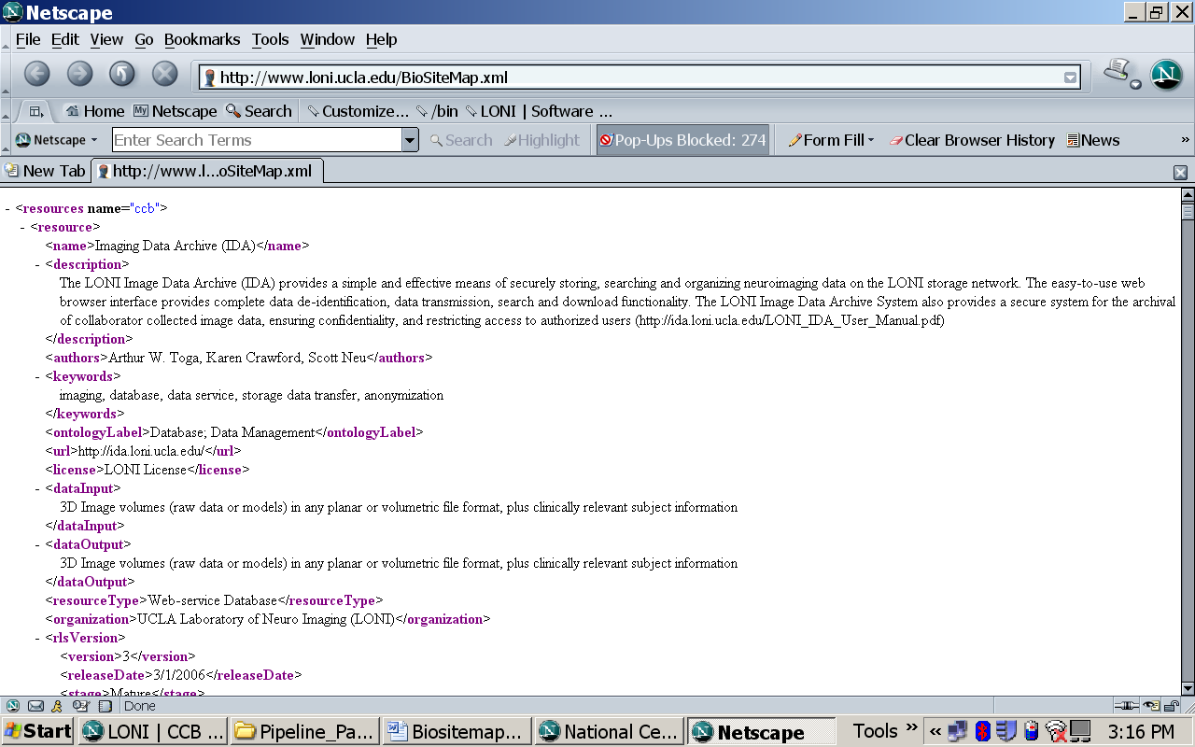

At his point, there is a valid and complete Biositemap.xml file constructed, which represents the biomedical resources developed and disseminated by one center, group, institute or organization.

- Dissemination of Biositemaps
  - Place this Biositemap.xml file in the proper (root URL directory) online.
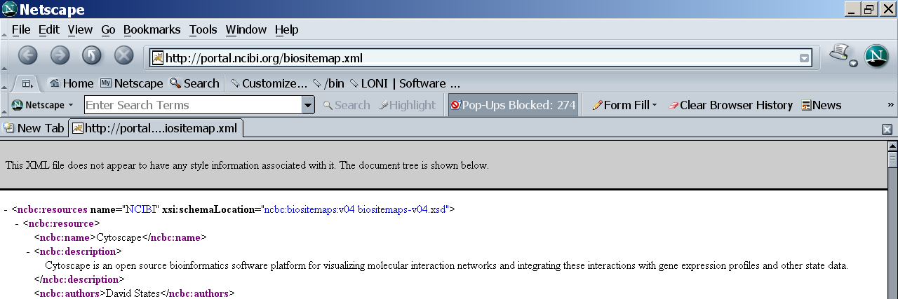

  - Wait for Yahoo and other web search/query engines (e.g., iTools Crawler) to find see this new Resourceome Biositemap.xml file. This may take up to 2 weeks.

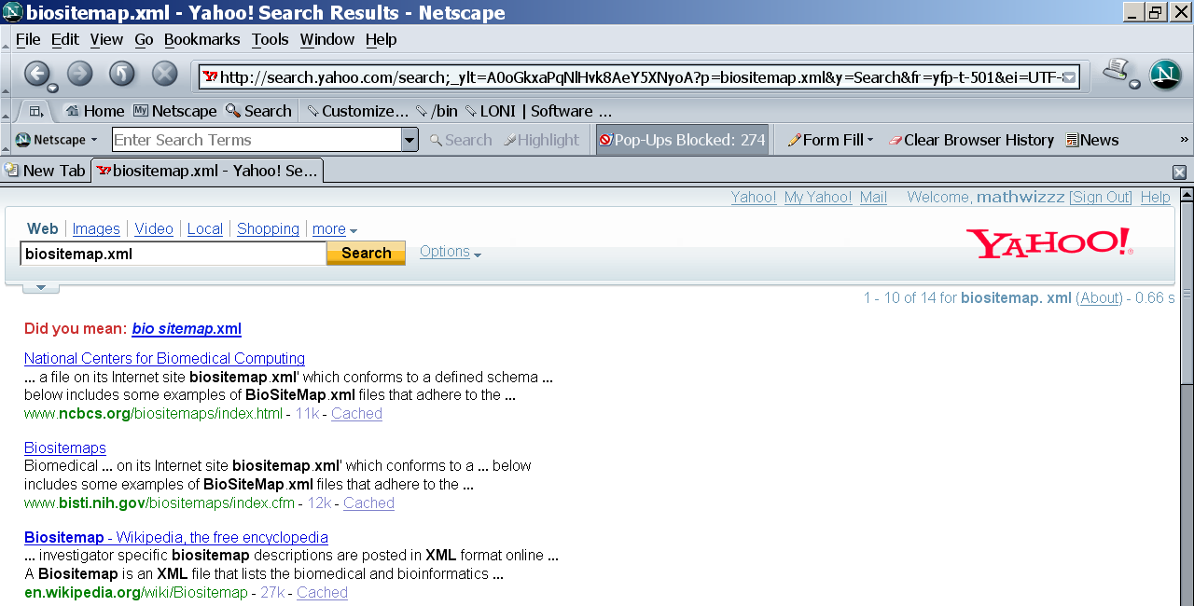

At this point you have correctly and widely broadcasted your Resourceome to the entire community via the NIH Biositemap protocol. To validate, try a common web search to find your Biositemap.xml file via a “biositemap filetype.xml site:your.site.org” site-specific search, using any search engine.

- Utilization of Biositemaps
The utilization of your Biositemap Resourceome will vary based on who, why and how is interpreting your computational and biomedical Resourceome.
  - Biositemap users – the following are the most common human users of Biositemap Resourceomes.
    - Funding Agencies
    - Colleagues and collaborators within your discipline
    - Researchers and investigators from other fields
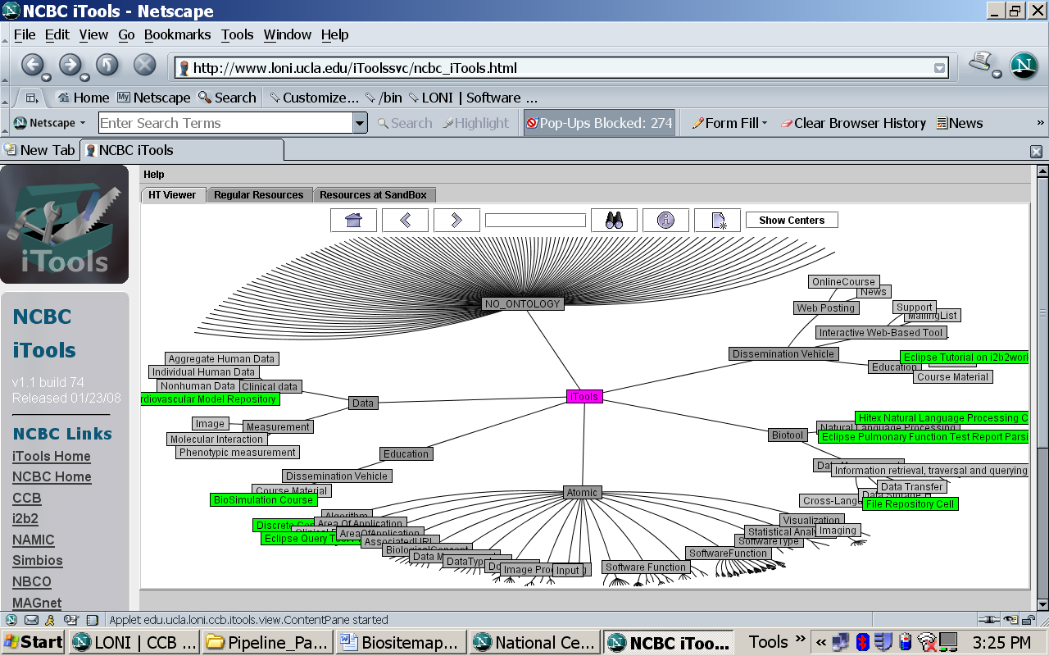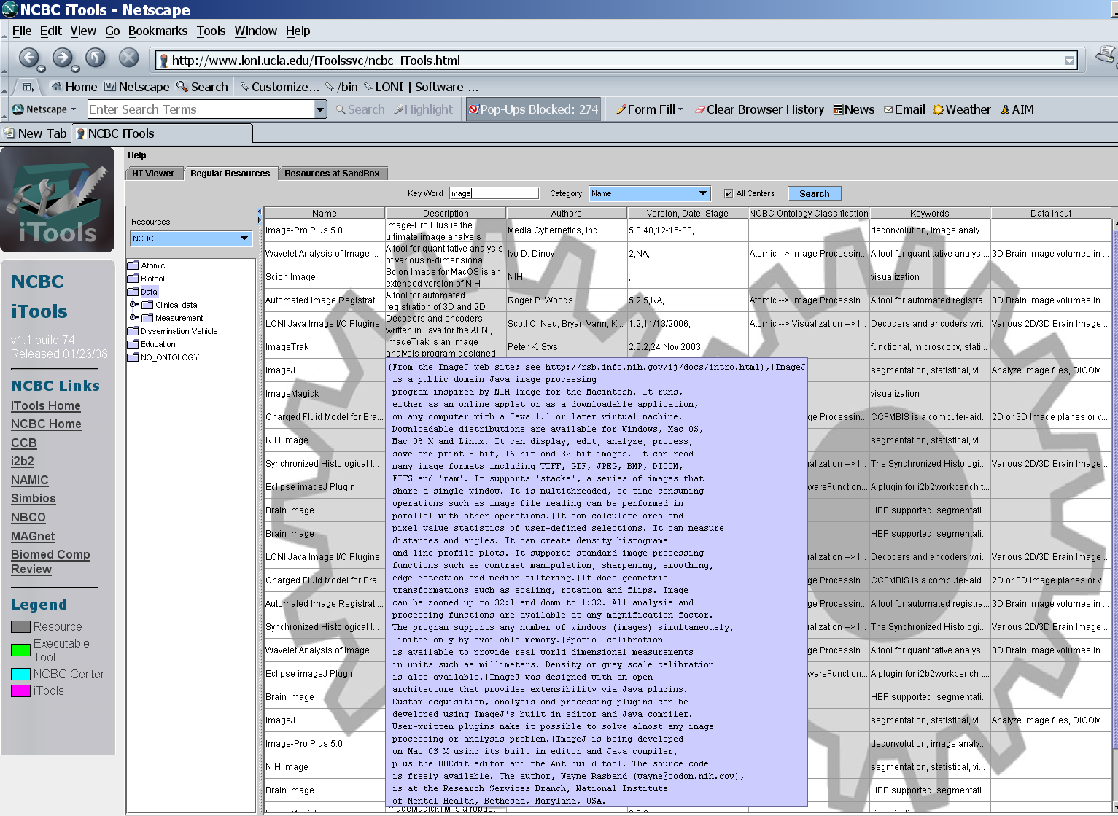

  - Meta-Resourceomes – machine-based Resourceome interpreters

    - iTools (iTools.ccb.ucla.edu)
    - NSDL (nsdl.org/browse/ataglance/browseBySubject_netmac.html)
    - Others (www.loni.ucla.edu/twiki/bin/view/CCB/NCBC_ToolIntegration_XMLtology_2006_OtherArchives)



