Crop Tool and Grow Cut Segmentation Tool Tutorial Using Bladder Images
By Tyler Blevins

Open Slicer. The Slicer main page welcomes you.
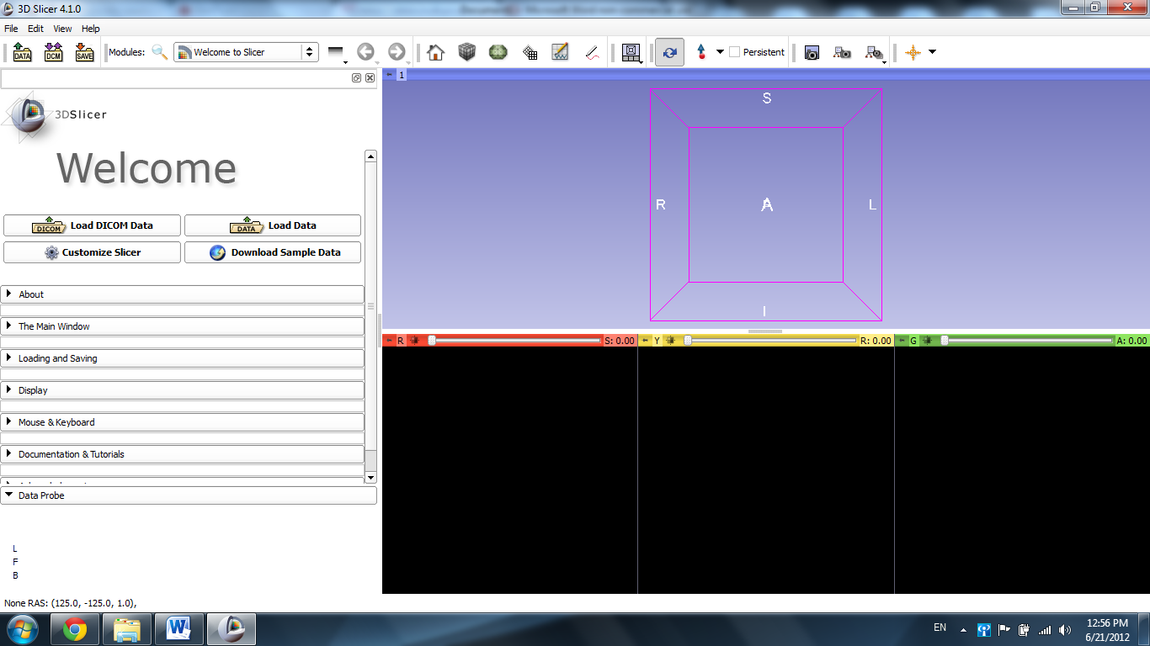

Open the File tab and select Add Data.
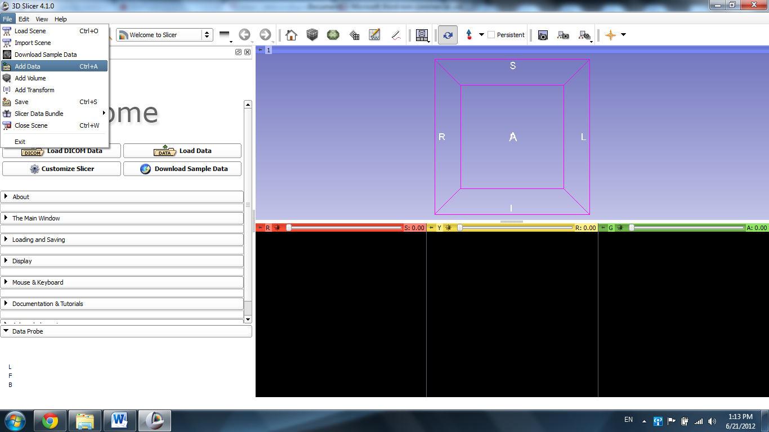

Click Choose File to Add
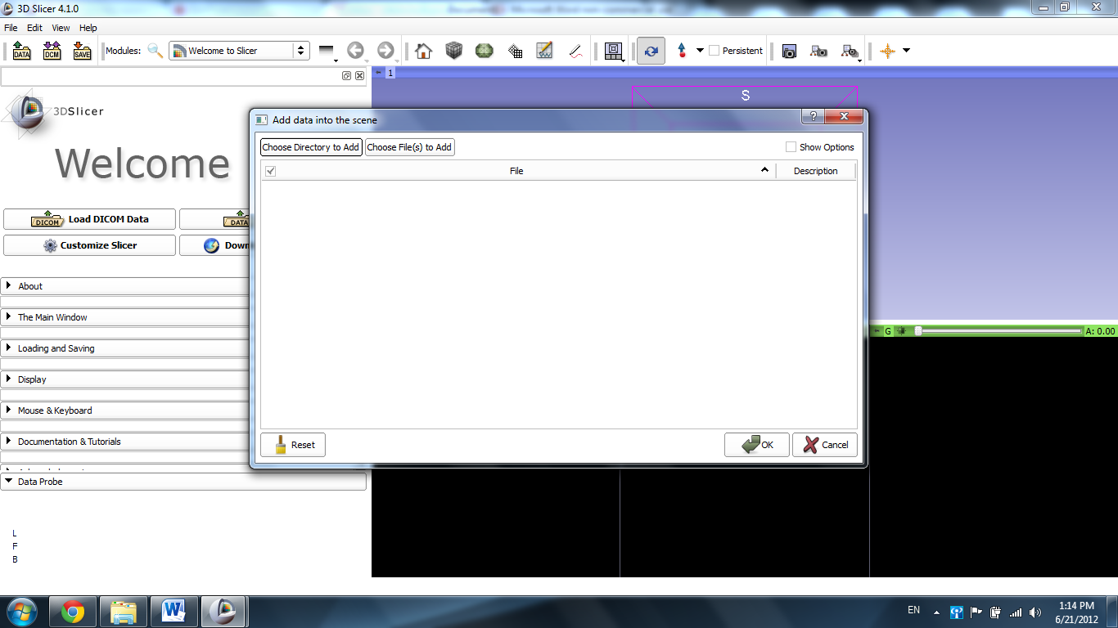
Choose the file “Case 19_007_AX_3d_truefisp_for_pelvis.nrrd”

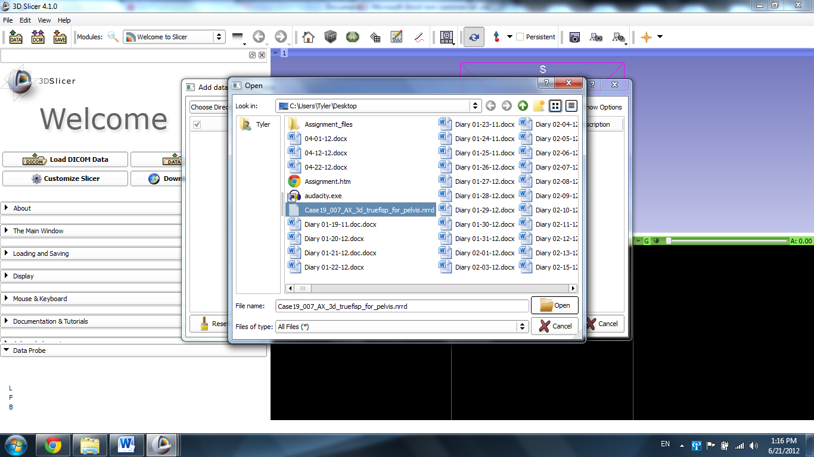

Click OK.

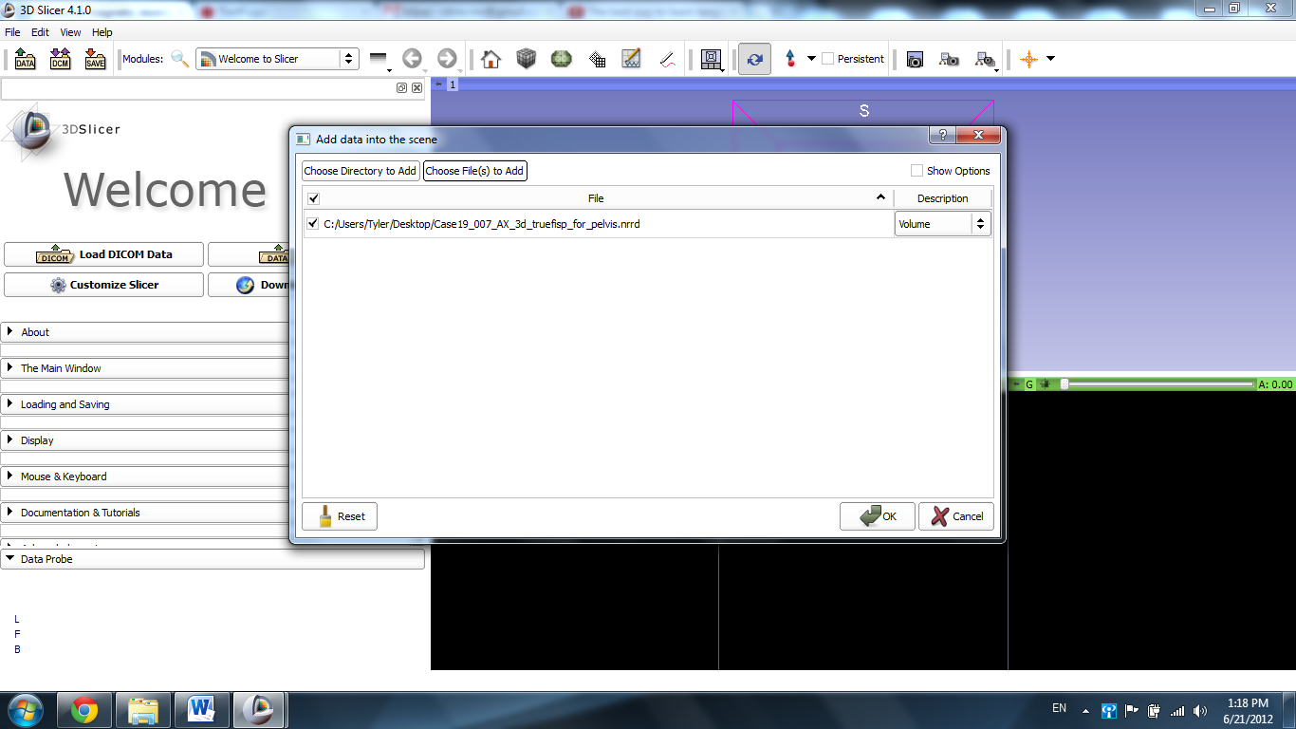

The scene loads MRI scans of the pelvis into the Slicer windows.
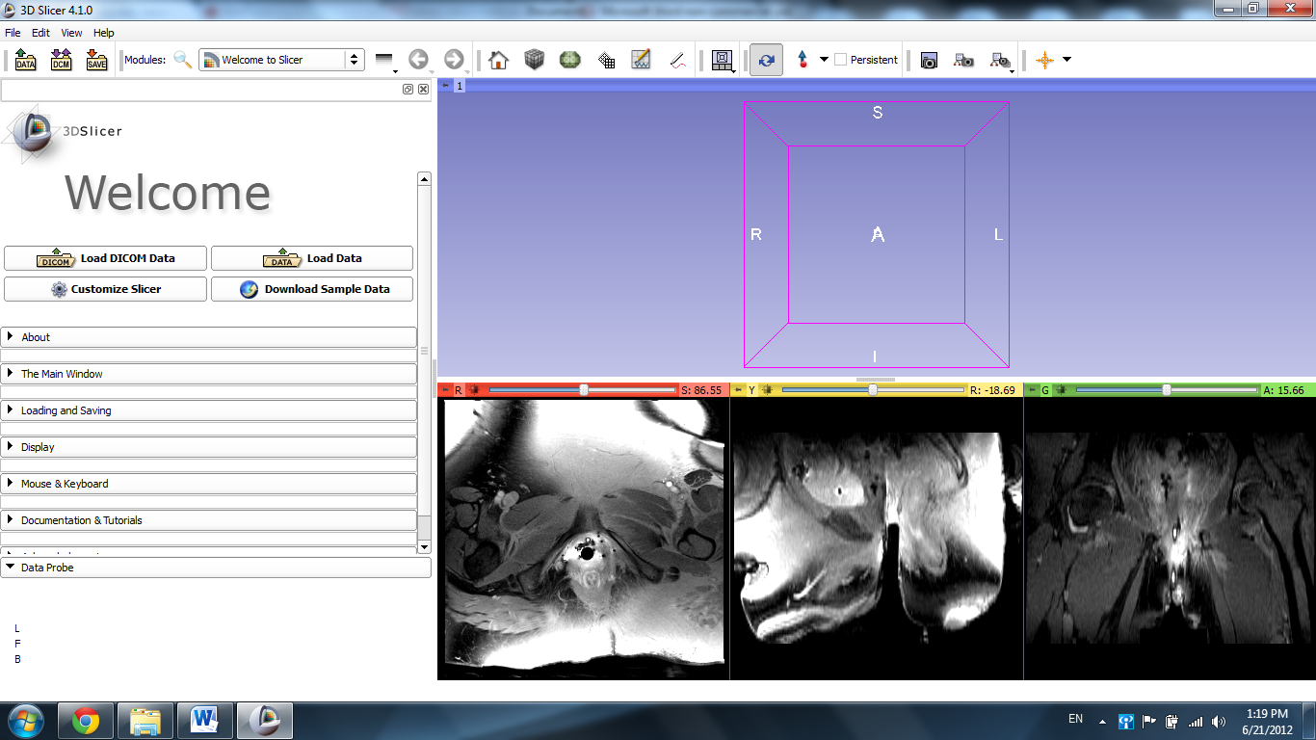

Open the Modules tab and open the All Modules selection to display the 100+ different modules Slicer has to offer.
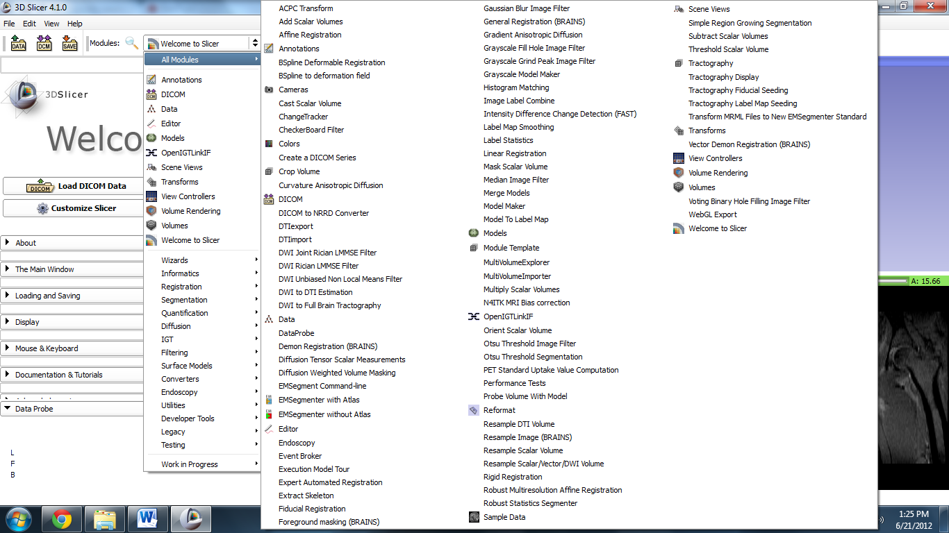
Click on the Volume Rendering option.
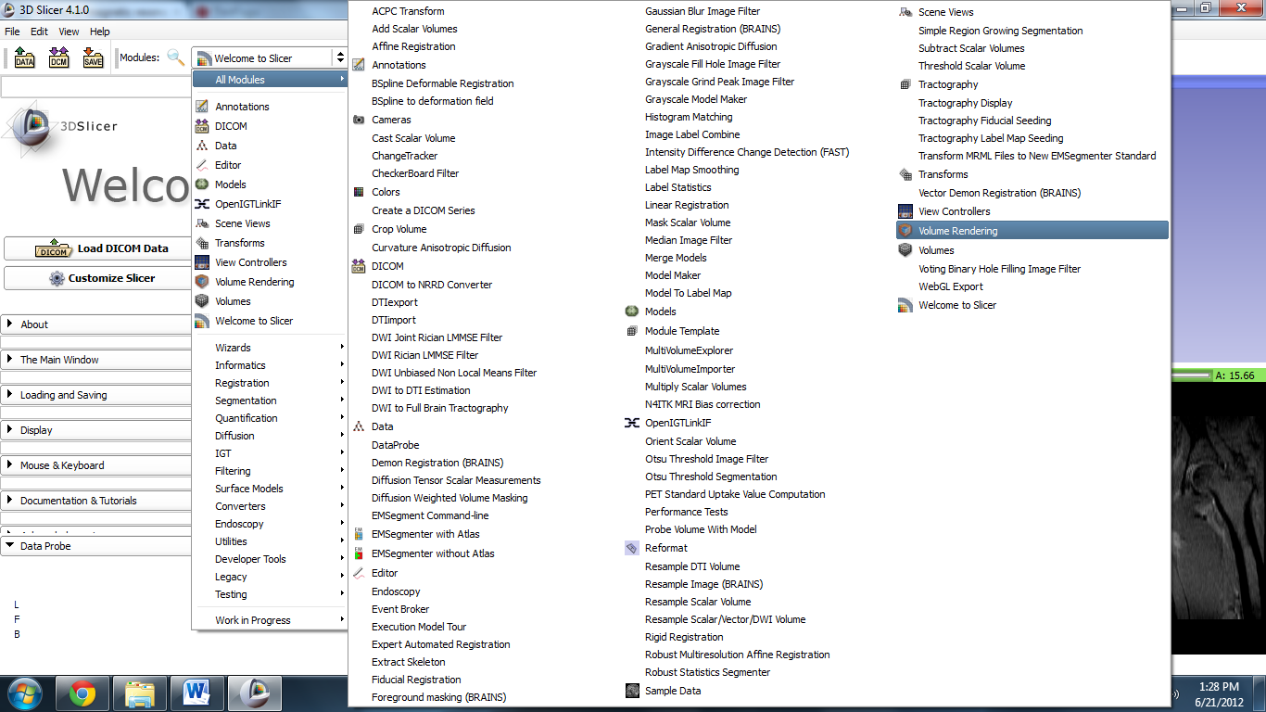

The module appears in the sidebar.
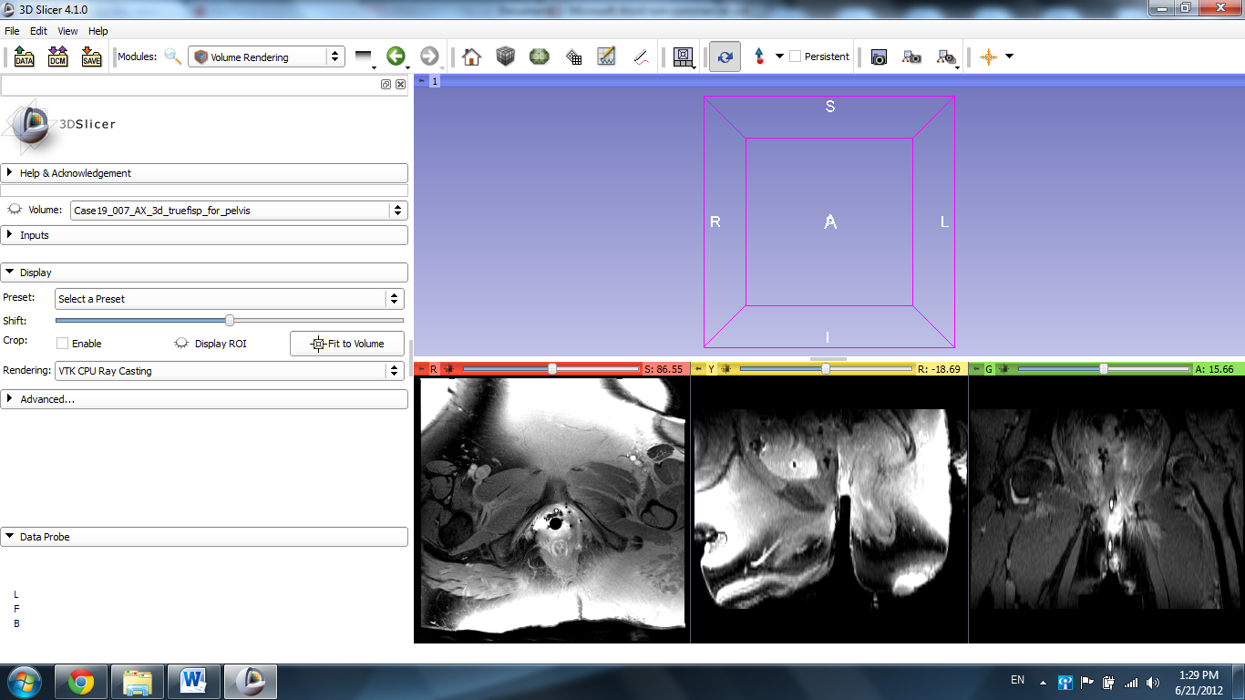

Click the eye icon next to the Display ROI description. The cropping parameters appear in the 3D viewer and the slides.
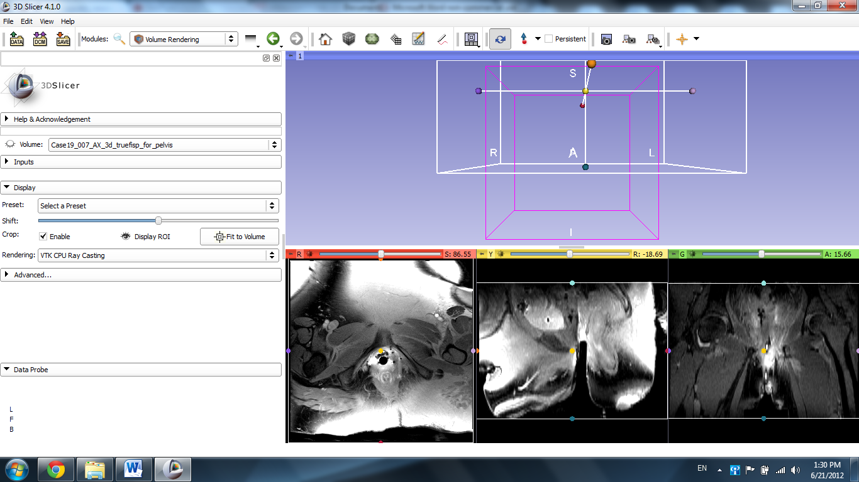

Switch the viewer to Red Slice Only.
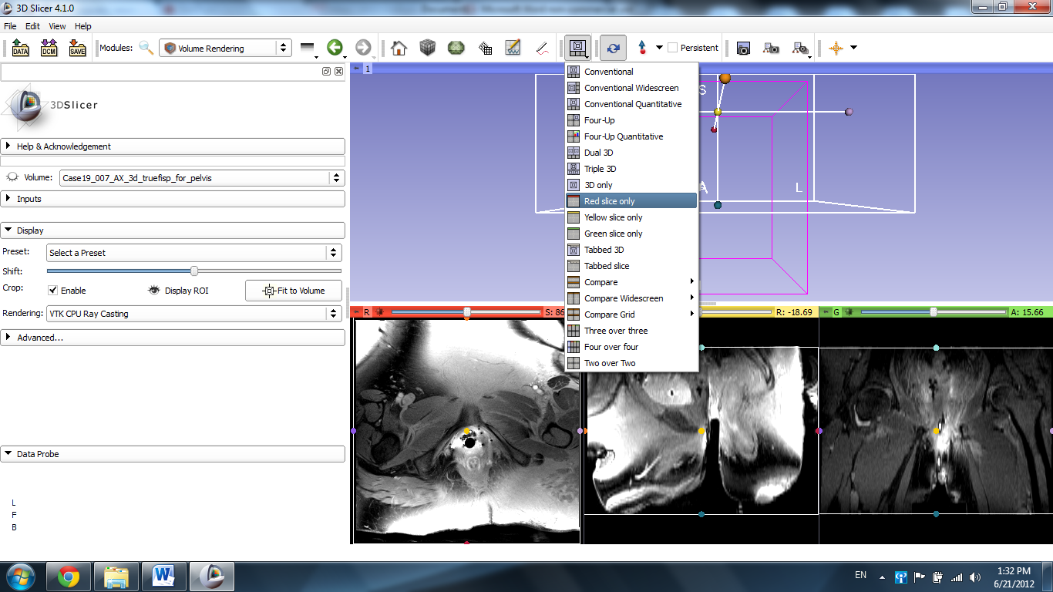
The Red Axial Slice appears in the main viewer window.
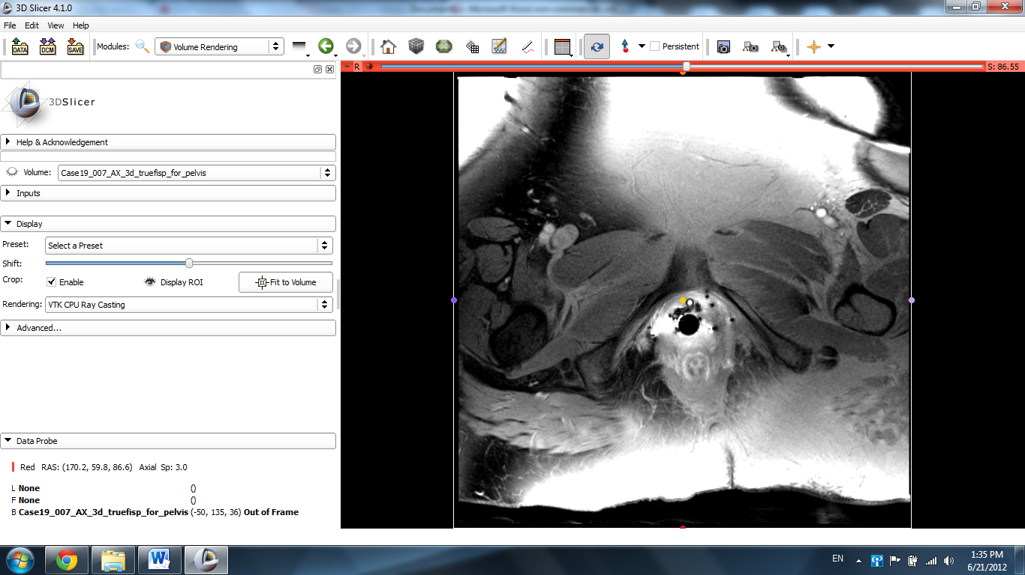

Scroll through the slices using the mouse wheel, the track pad, or the slider at the top of the window until the bladder is located.
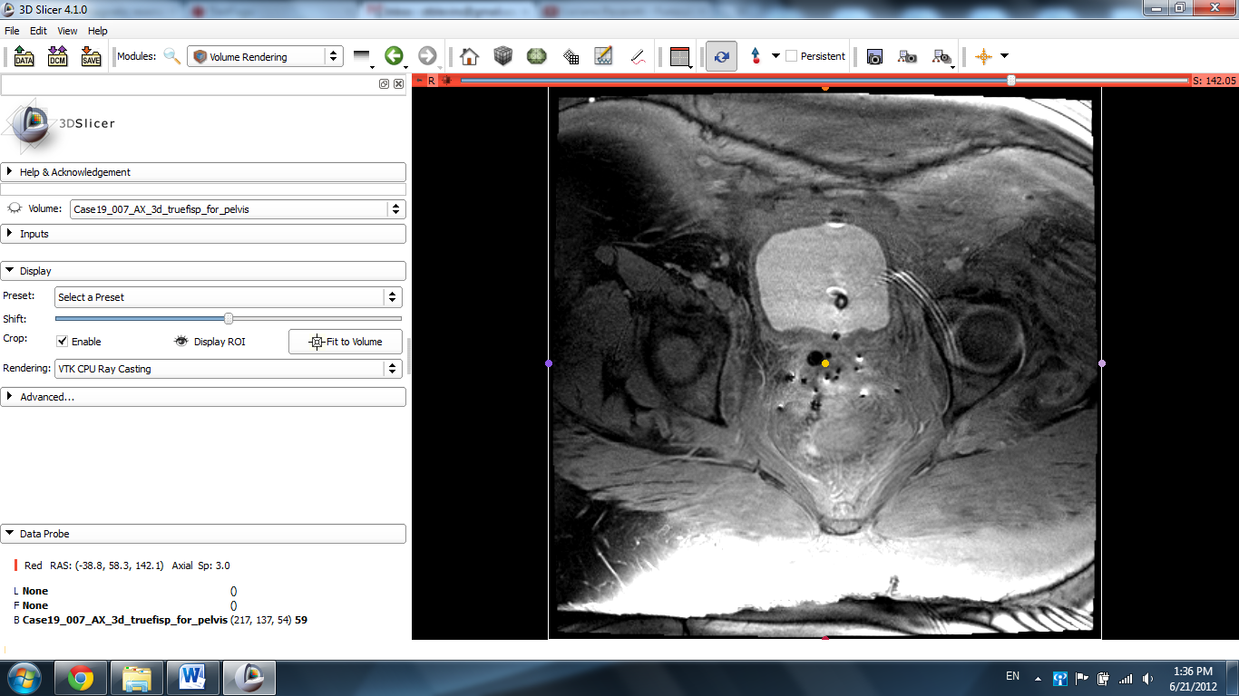
Drag the boundaries of the cropping window until they encircle the organ of interest (the bladder, in this case) with reasonable space around it.
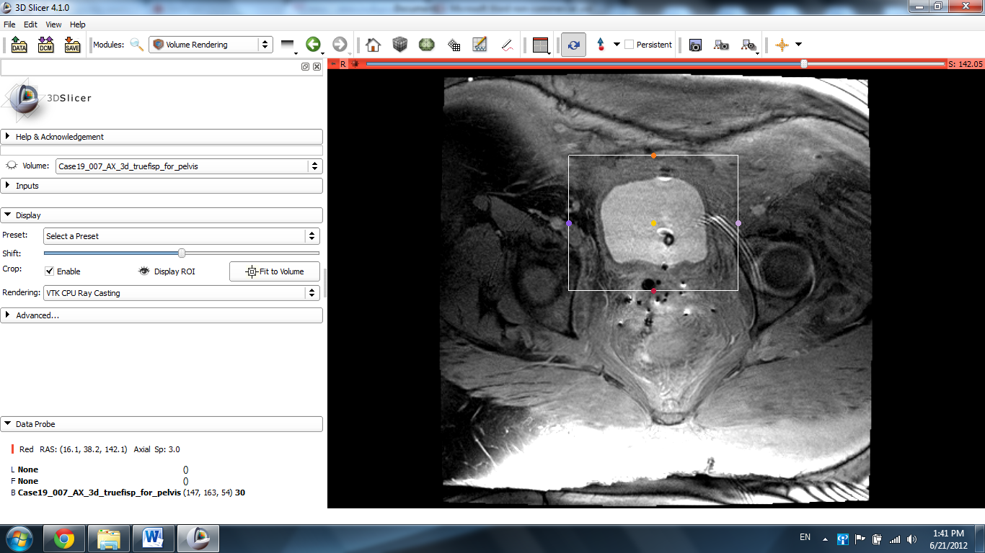

Note: If the crop box does not appear, click the Advanced tab, then the ROI tab, and click the ey icon next to the description “Display Clipping Box.”
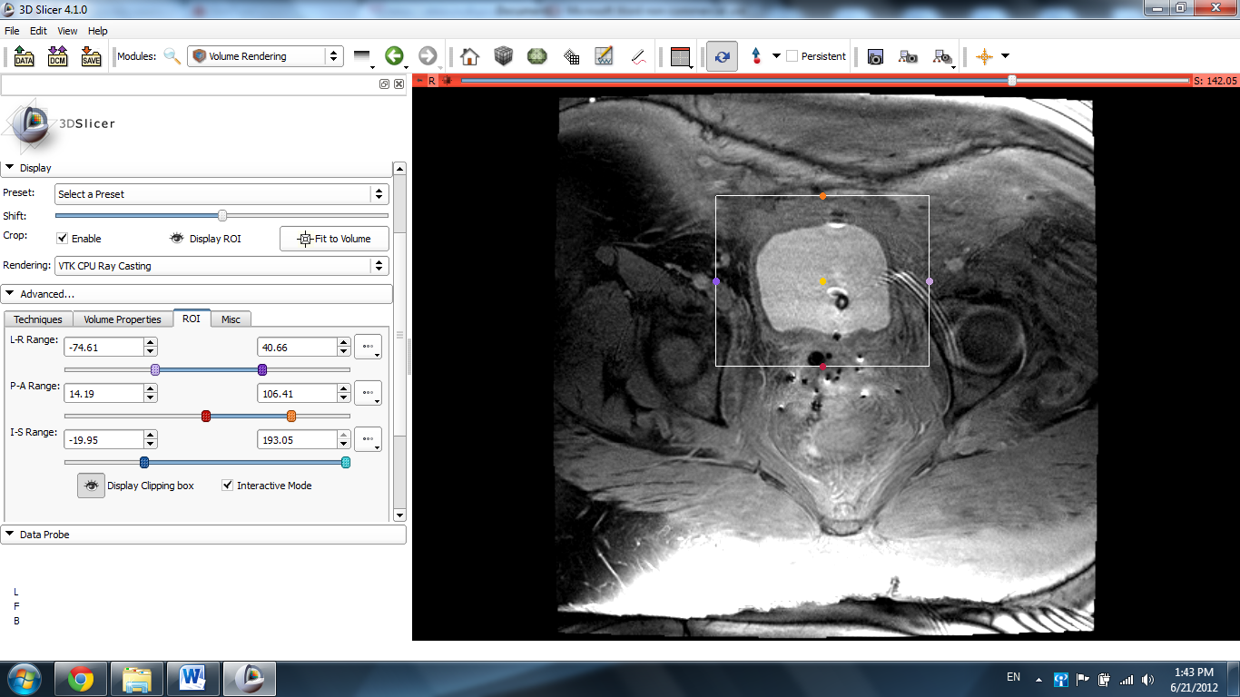

Open the Modules tab again, select All Modules, and choose the Crop Volume module.
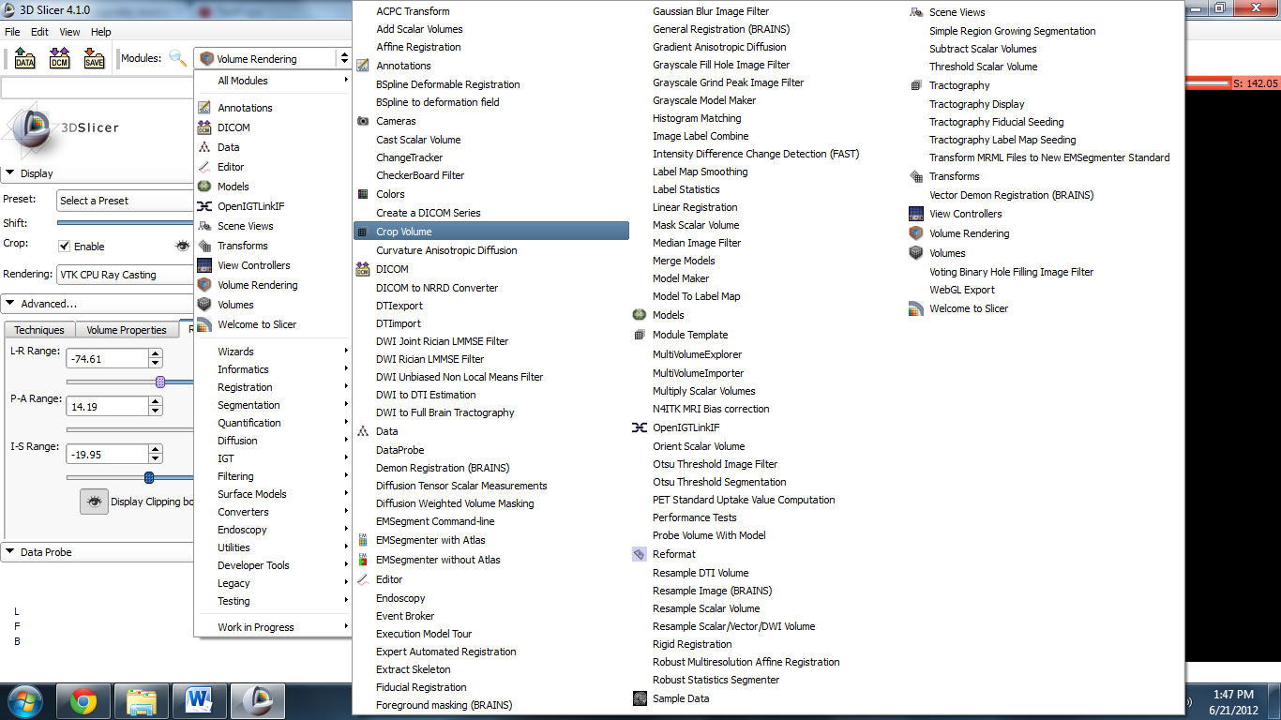

Click the eye Icon next to “ROI Visibility” if the clipping box is still not visible. Click the Crop! Button to crop the image to the parameters you have set.
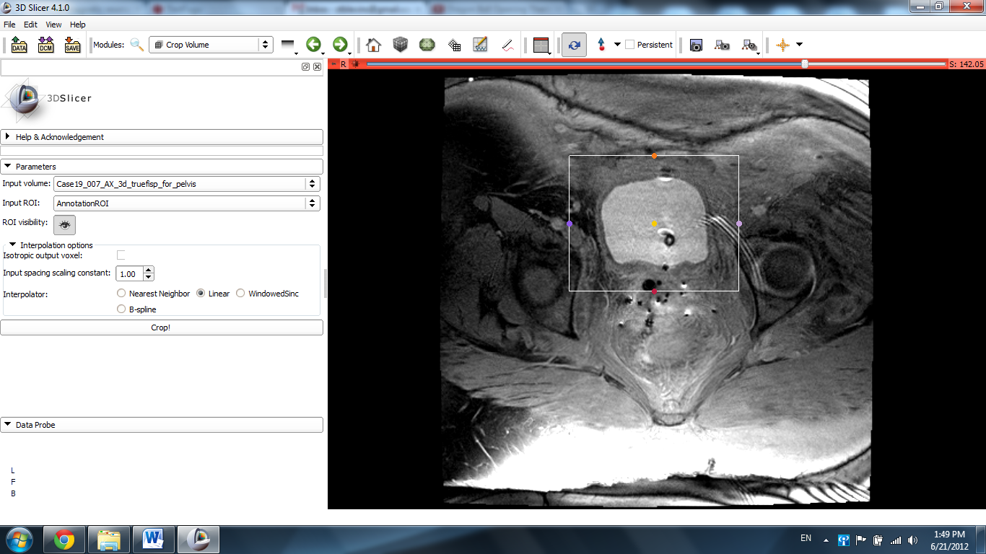

The cropped image will restore to its default setting before the slides were adjusted to find the bladder. Scroll through the slides again until the liver is located, noticeably larger than it was previously.
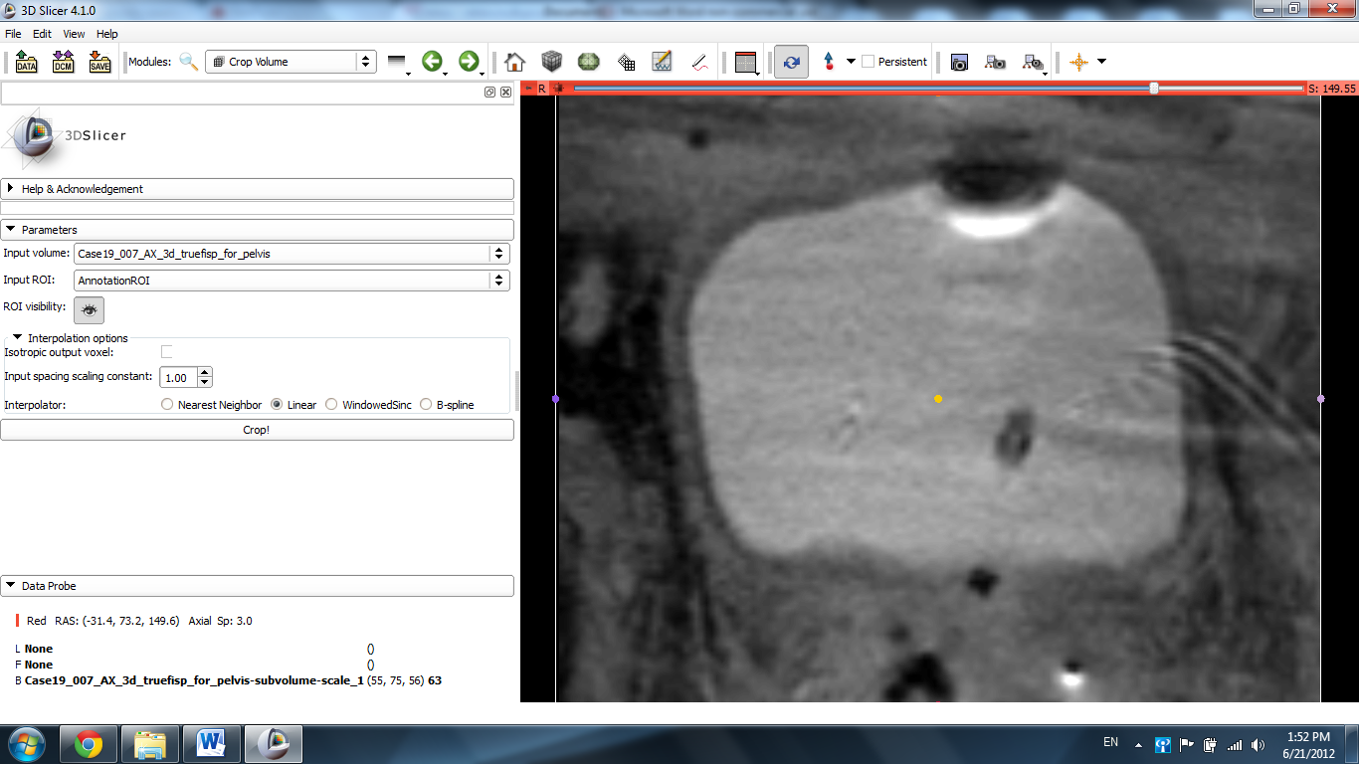

Click on the Modules label again and select the Editor module.

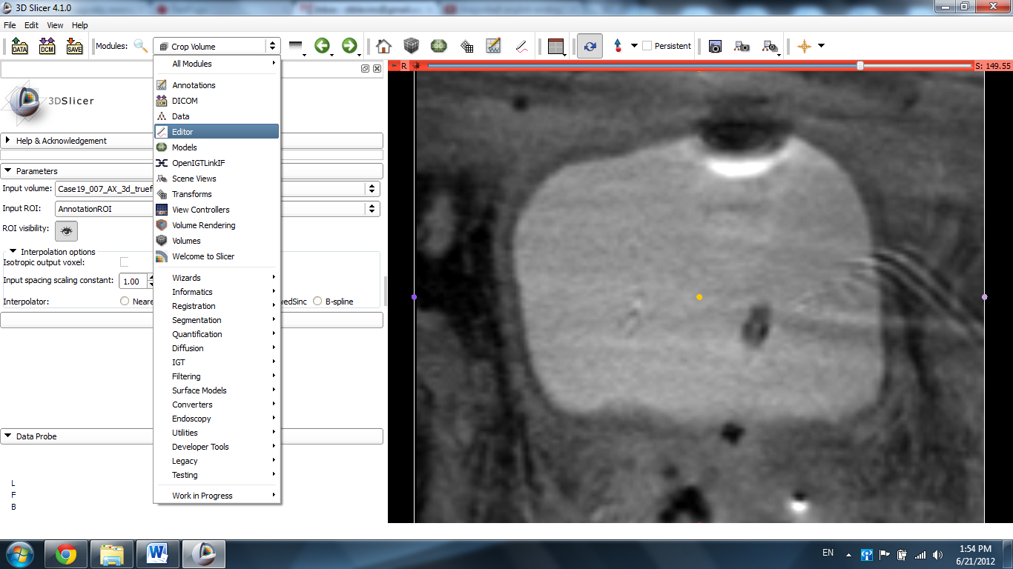

Click Apply.
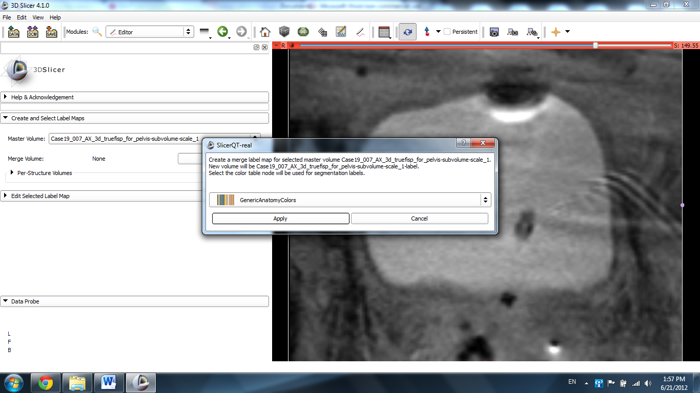

Select the Paint tool from the icon list.
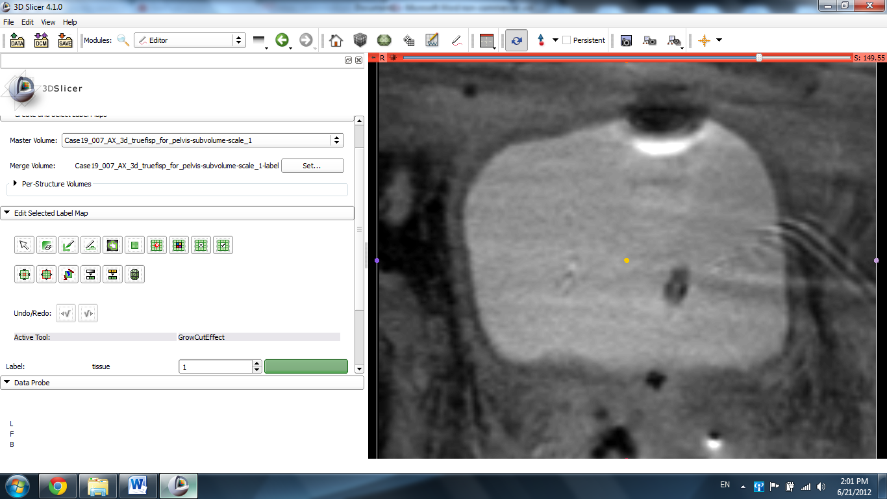

Use the paint tool to make a mark/gesture on the bladder.
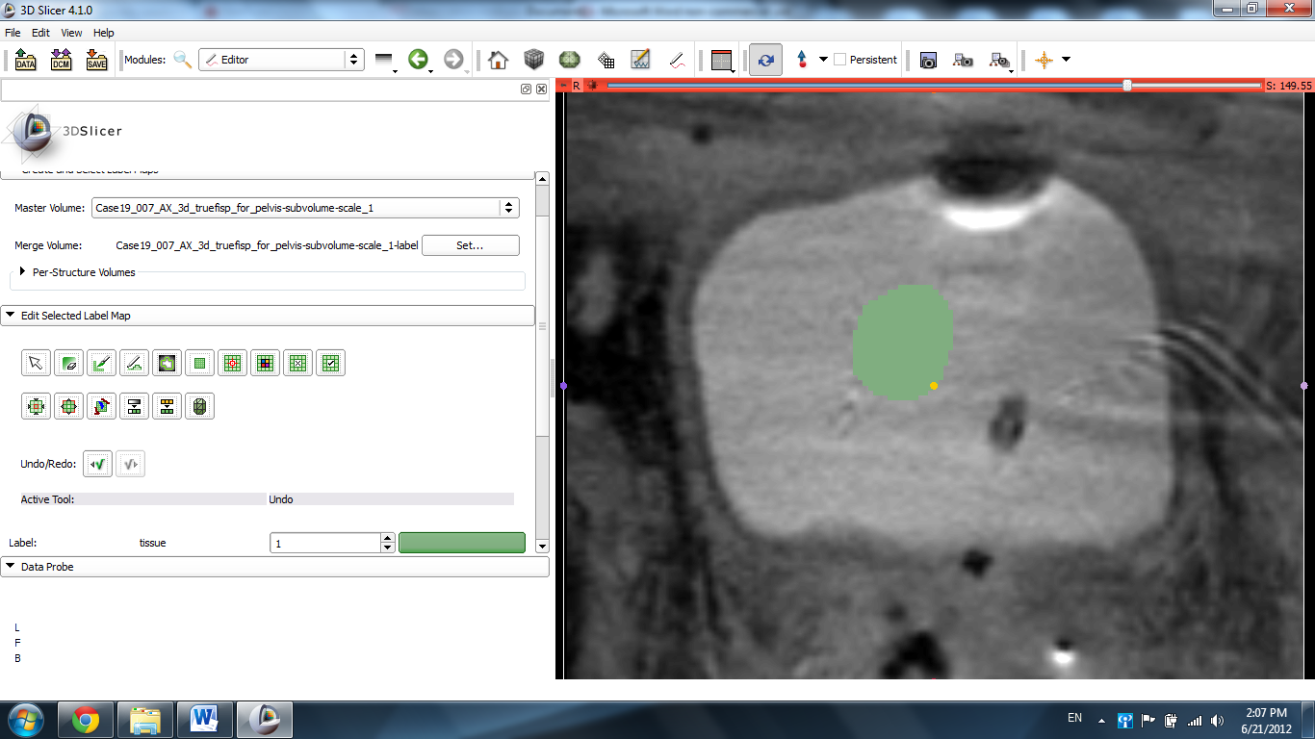

Change the color of the label using the up and down arrows of the label tool and draw a circle around the bldder.
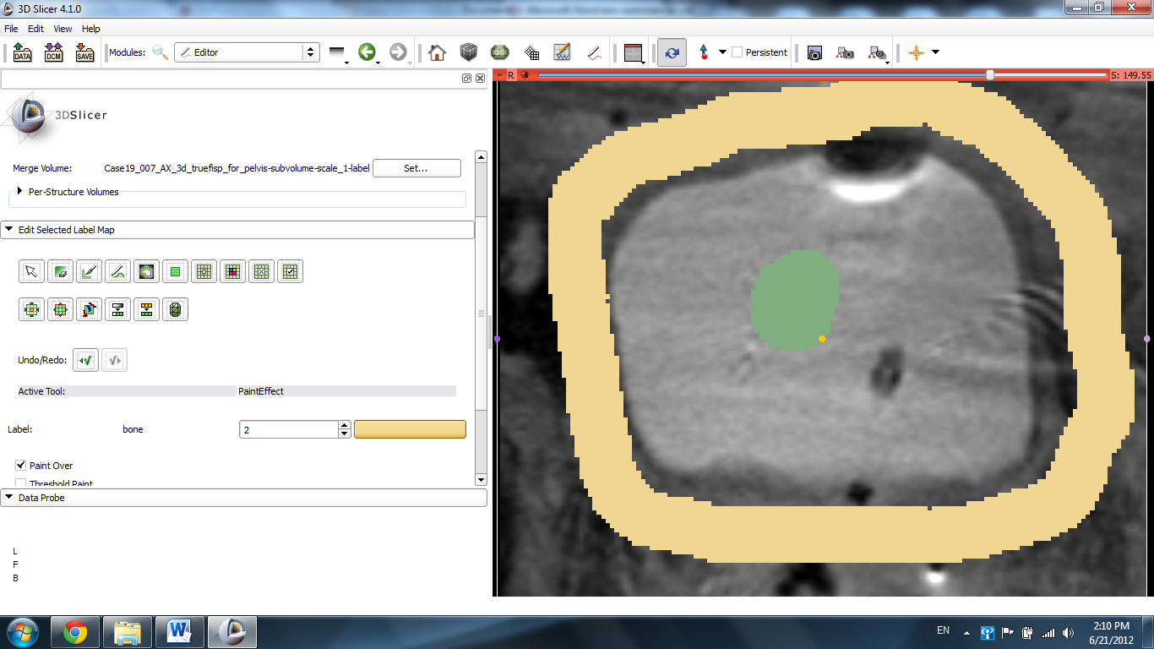

Select the Grow Cut Algorithm.
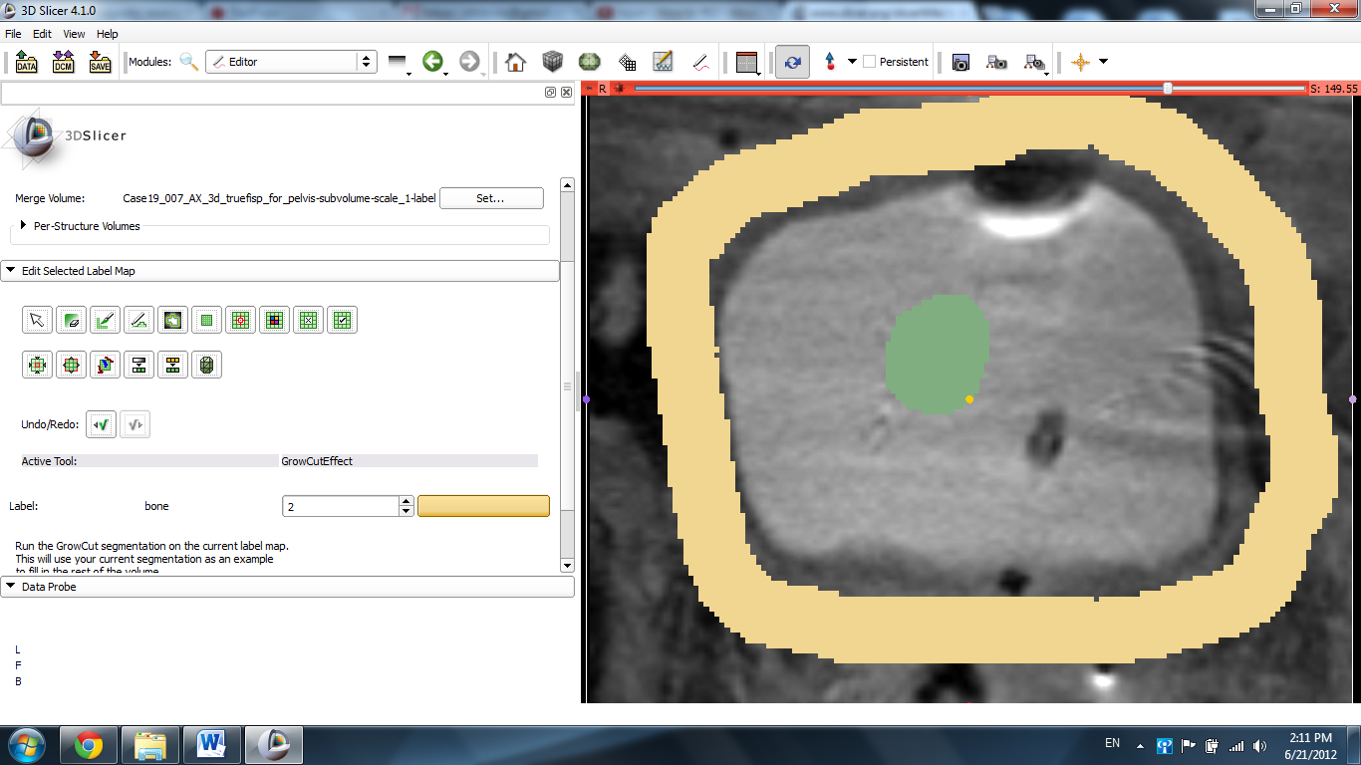

Scroll down to the bottom and click on Apply.
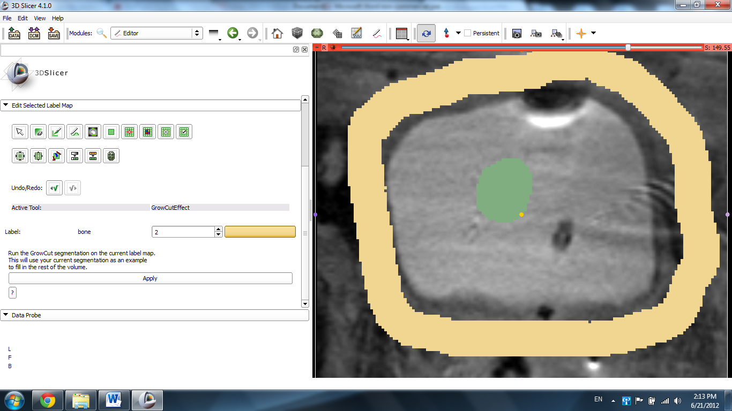

Slicer displays the results of the algorithm.
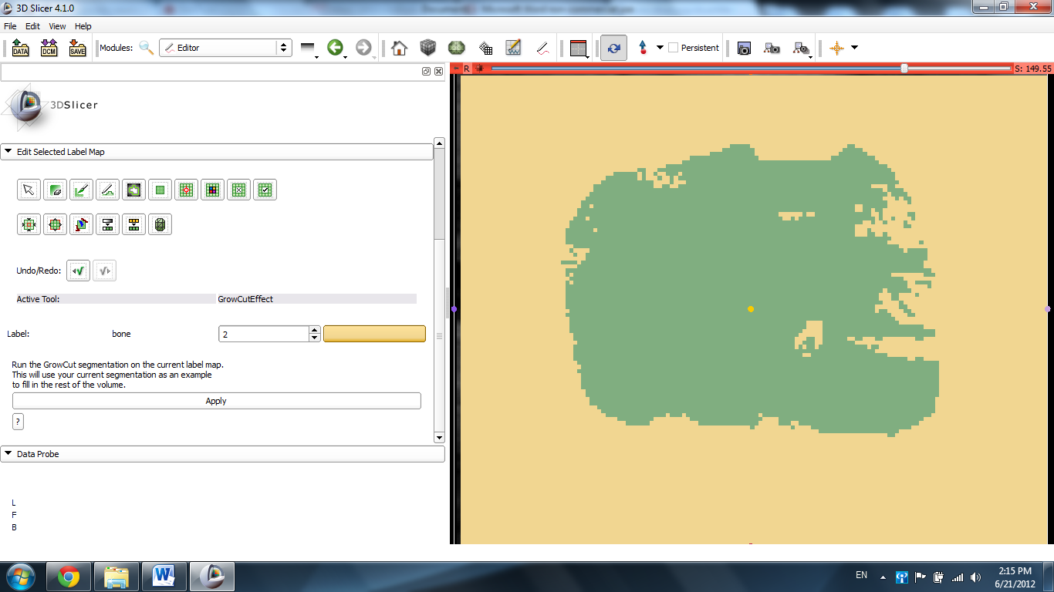

Select the Change Label Effect and set the Input and Output settings to 0 and black and click Apply.
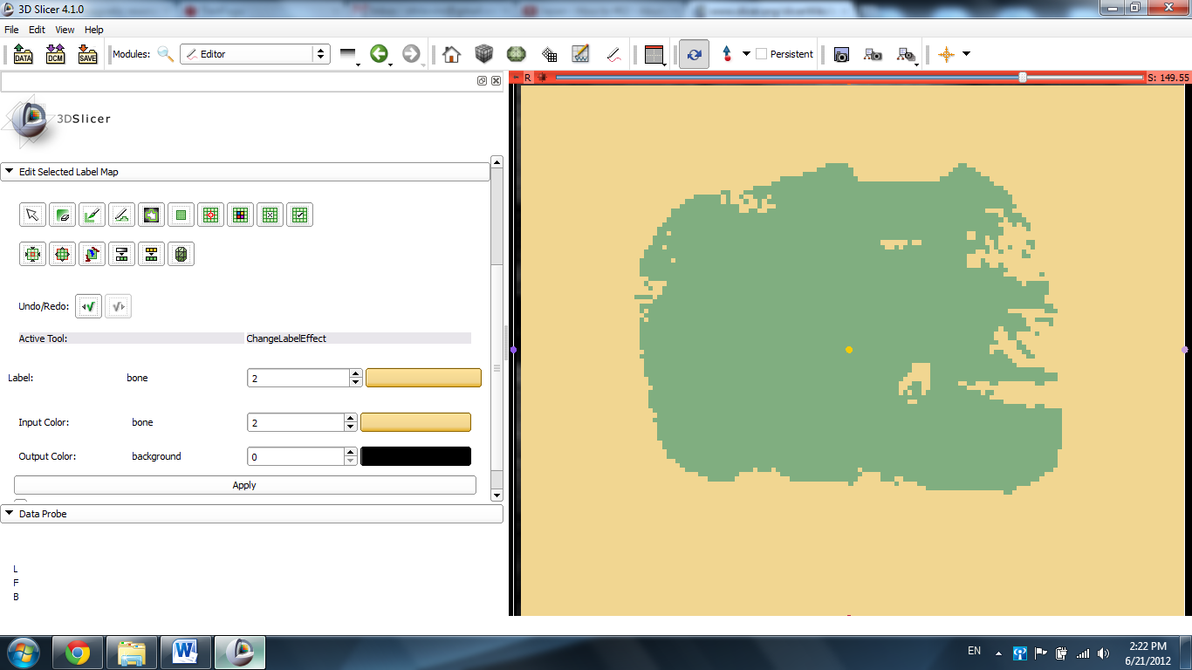
Slicer displays the labeled organ.
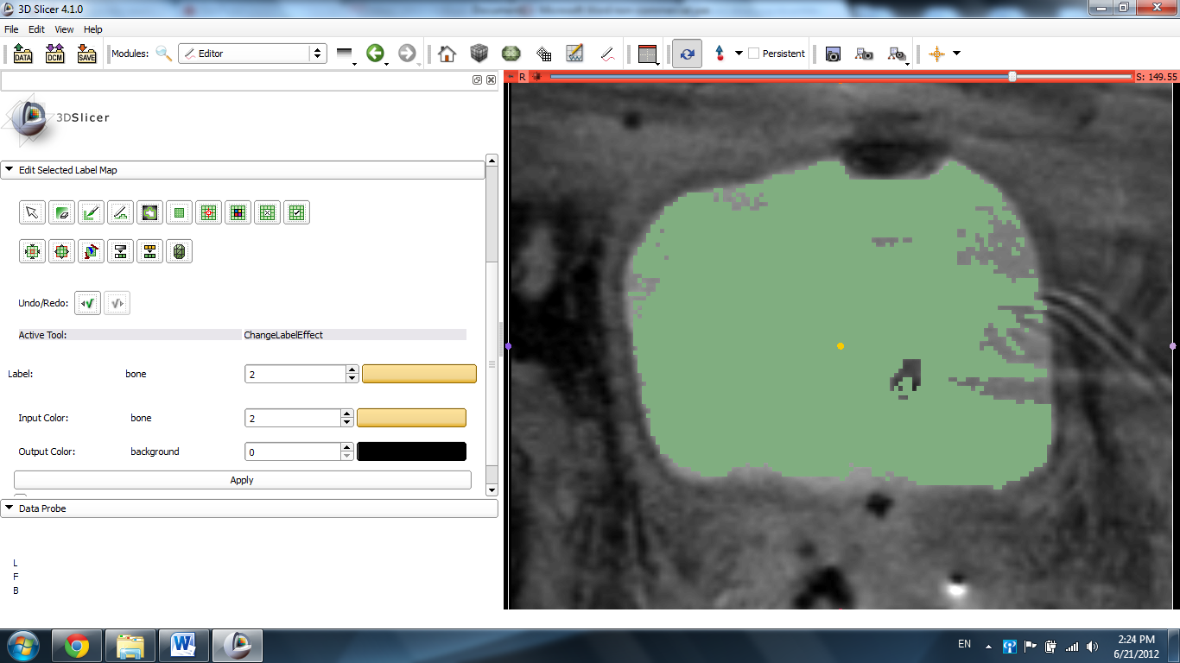

Click the pin icon in the top left corner of the slide and click the link icon.
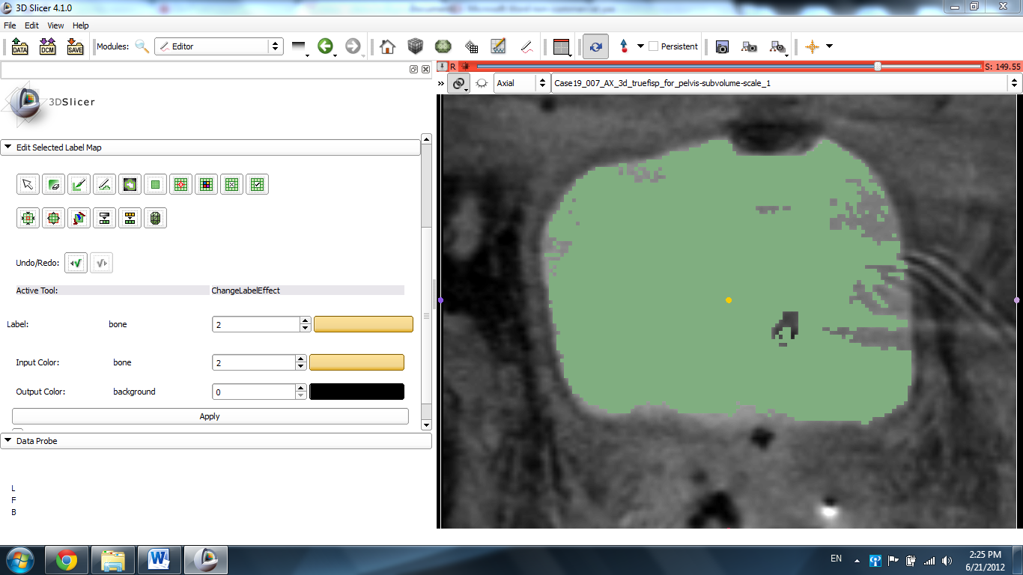

Click the double arrow icon and hover the mouse over the mouse over the numbers next to the eye icon. Drag the slider until the numbers read ~0.50. The label fades away enough to reveal the organ.
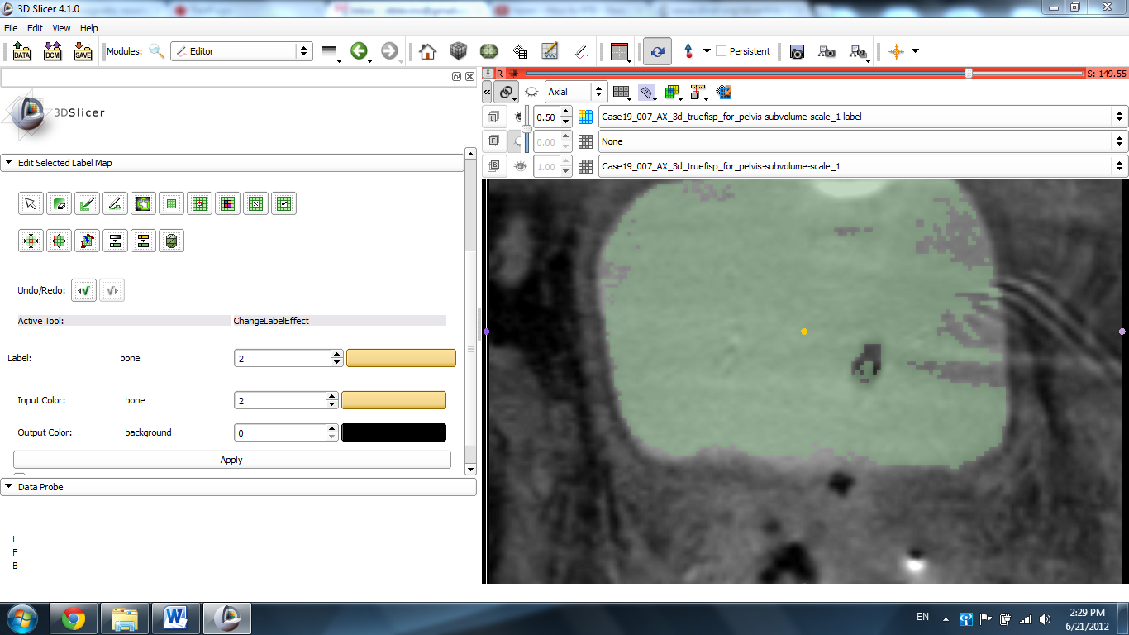

Click the viewer tab and select Conventional View.
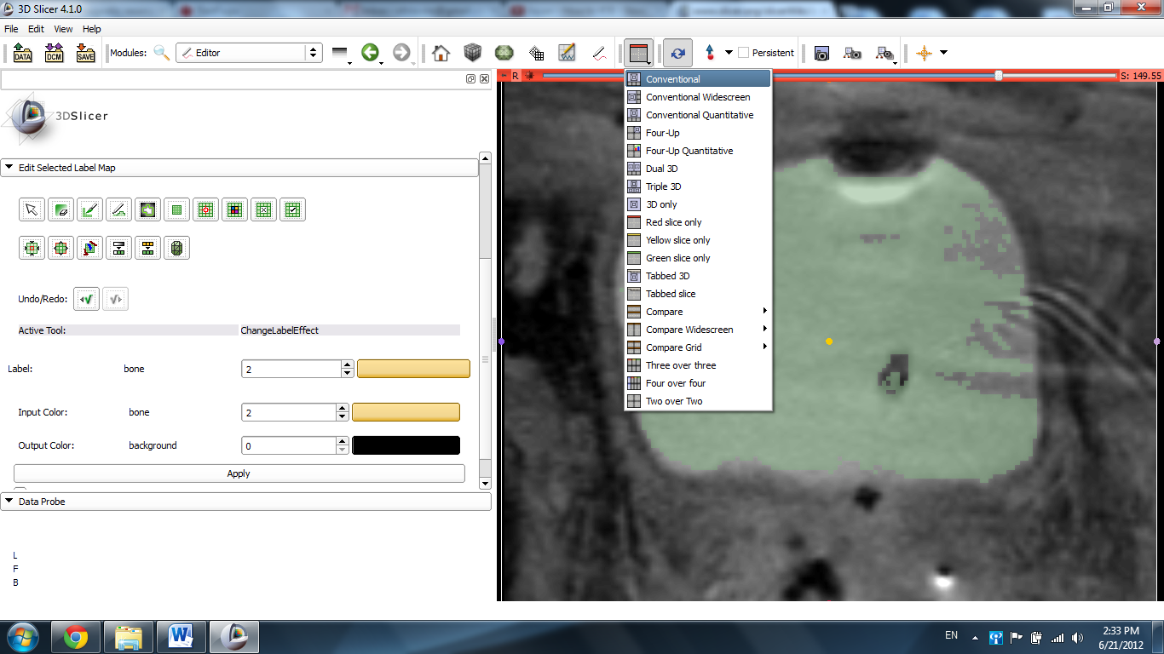
Click the Save Island Effect icon and click on the bladder label.
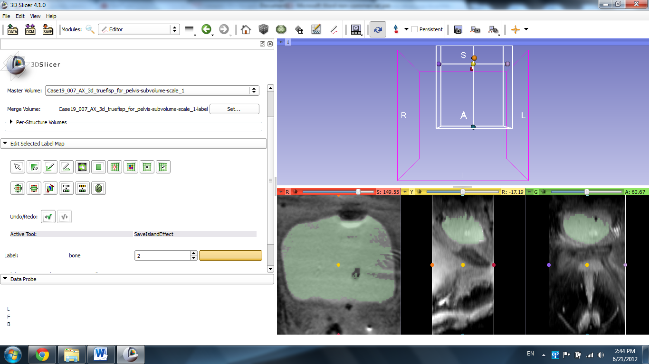

Click the Per Structure Volumes Tab and Split Merge Volume, and then click the label that corresponds to the label you applied.
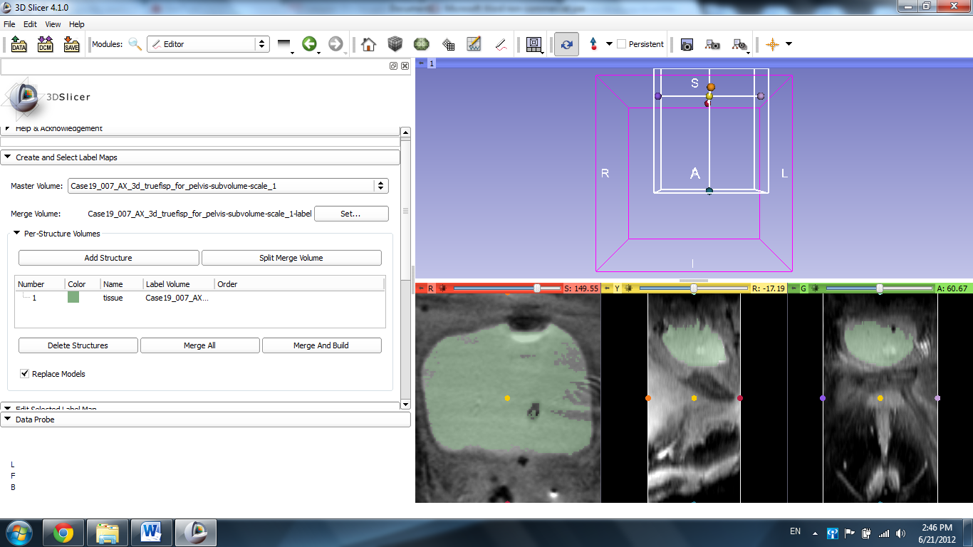
Click Merge and Build to generate the 3D image.
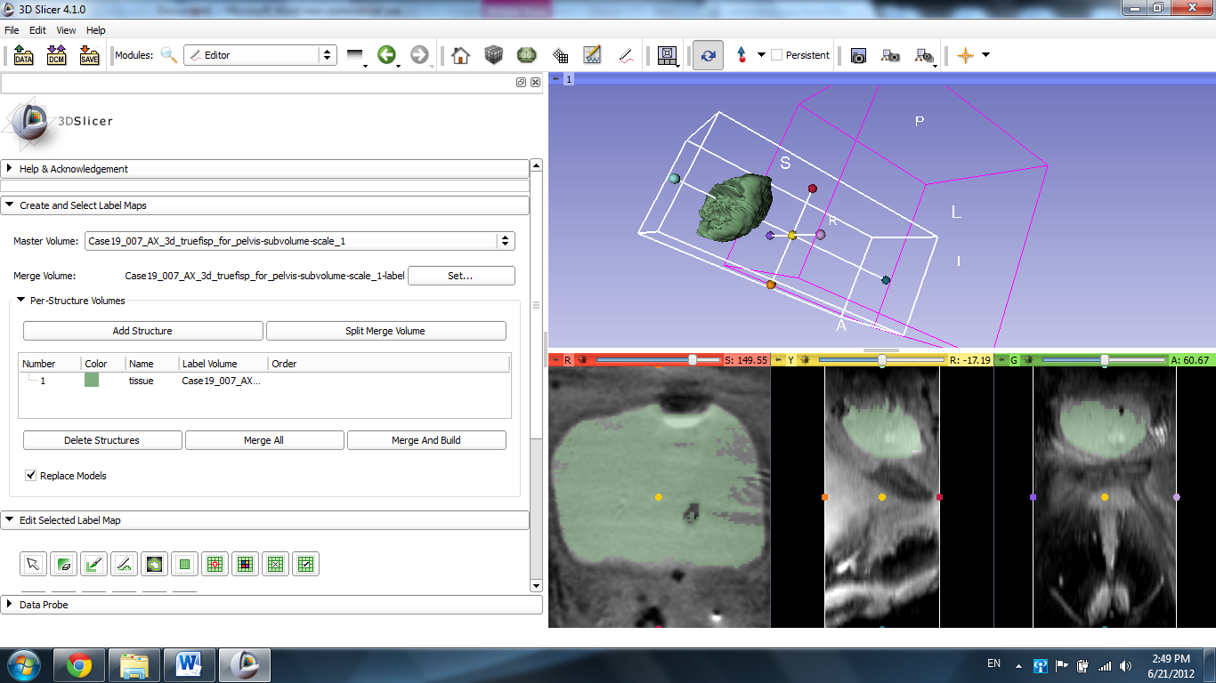

To center the 3D image, click the pin icon in the top left corner of the blue slide with the image and click the Center Image icon.
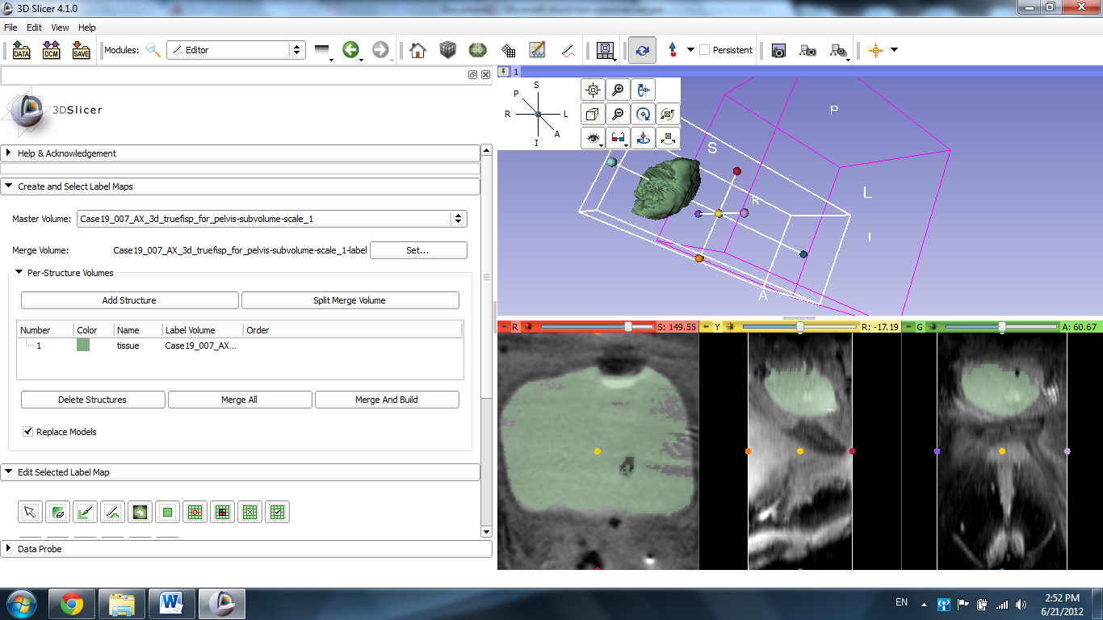
The 3D image centers itself in the window.
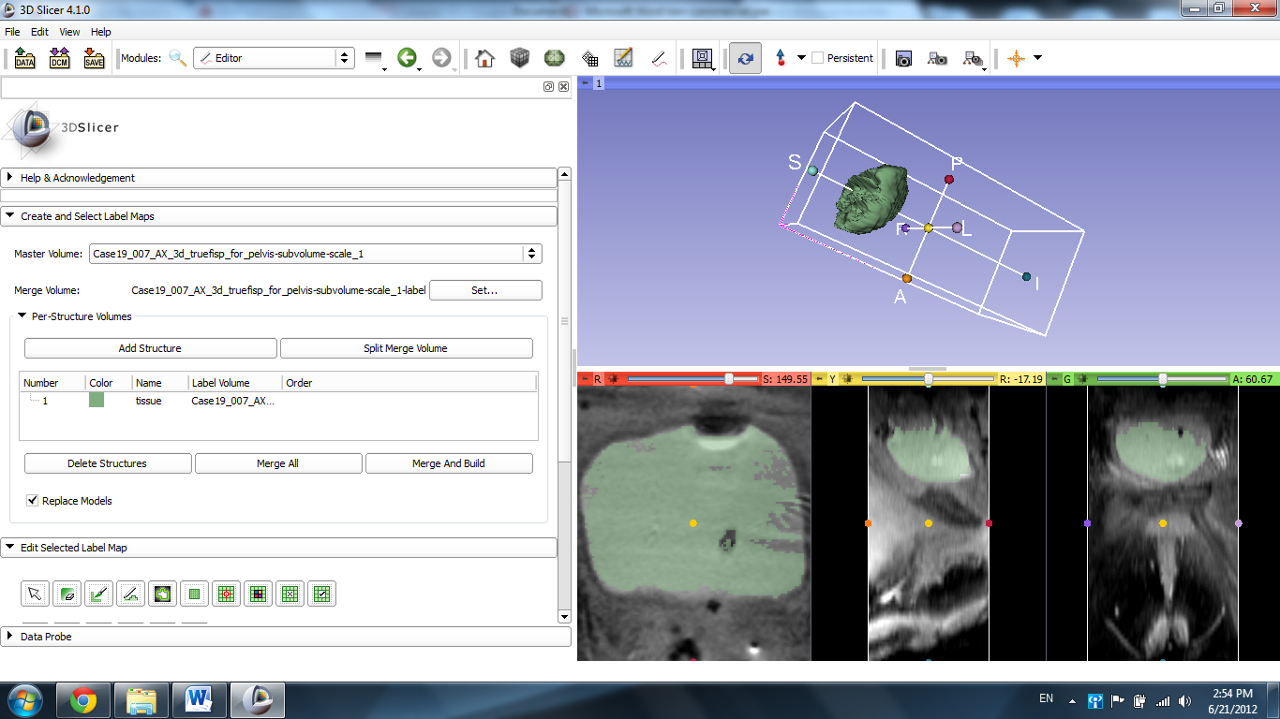

Finally, click the pin in the top left corner of the red slice and click the eye icon to display the slides in the 3 window.
